# Development

This section outlines the development process, technologies and implementation. This explains both the big picture decisions of how to structure the code and the implementation of individual methods. All screen shots are of the code and UI as it is at the end of development.

## Overview of Technologies

The back-end is hosted on AWS utilising AWS lambda to provide server-side logic and AWS RDS to provide a database. AWS RDS was chosen as it is a fast reliable service that can be easily scaled to meet the needs of the application. AWS also allows for one free RDS instance and so I am able to use it for this project free of charge. The database is a MySQL database as it is reliable and easy to use, I also have previous experience writing SQL queries for MySQL databases. AWS Lambda was chosen as it is a serverless approach that allows for individual lambda methods to be created very quickly and efficiently. I also have experience creating lambda methods and I am able to use AWS Lambda free of charge up to 100,000 requests per month. Since 100,000 is far more requests than an individual would ever make, this allows for the development of Graduation Gathering to not occur any charge. The lambda methods have been written in Python as my previous experience with AWS Lambda was using Python.

The front-end of the application was written in Dart using the Flutter framework. Flutter allows for development for both iOS and Android and so only one front-end had to be written instead of two. I have previous experience with Flutter development for iOS and Android.

To render and interact with the map the OpenLayers JavaScript package has been used. This retrieves and displays an OpenStreetMap map. I have already built a Flutter application that uses OpenLayers and so I will be reusing that code for this project. The reuse of this code saves time in both the implementation of the code and the testing.

Git has been used throughout the development of this project to back up the progress made and to allow for version control. In order to properly allow for version control the branch features of Git have been used. GitHub and GitHub Desktop have been used to make using Git easier and so more efficient.

To manually test and debug the front-end software Android emulators were used provided by Android Studio.

## Sprint 1 – Project Start Up

The first sprint I undertook focused on creating an initial framework from which all other sprints could be based upon. By this I mean making a start in each area of the project and integrating each of the main technologies, packages and tools.

### Task 1 – Flutter Project Creation

The first task was to create the Flutter project and set up the initial UI. The initial UI is the base for the main screen of the application, the screen that you see once logged in. It has a bar at the top displaying the words “Graduation Gathering”, a navigation bar at the bottom that allows you to select which screen you would like to look at, and finally a space in the middle of the screen to display the content of the screen selected by the navigation bar.

### Task 2 – Navigation Bar

The next task was to add the logic for the navigation bar so that screens can be added efficiently in the future. This is handled in the file navigation_bar_items.dart through the class NavigationBarItems and the enum NavigationBarItemEnum. To add a new screen to the navigation bar first you add an enum for the screen that will hold the icon and name of the screen to be displayed on the navigation bar, as well as an integer that will hold the position in the navigation bar that the screen should be.

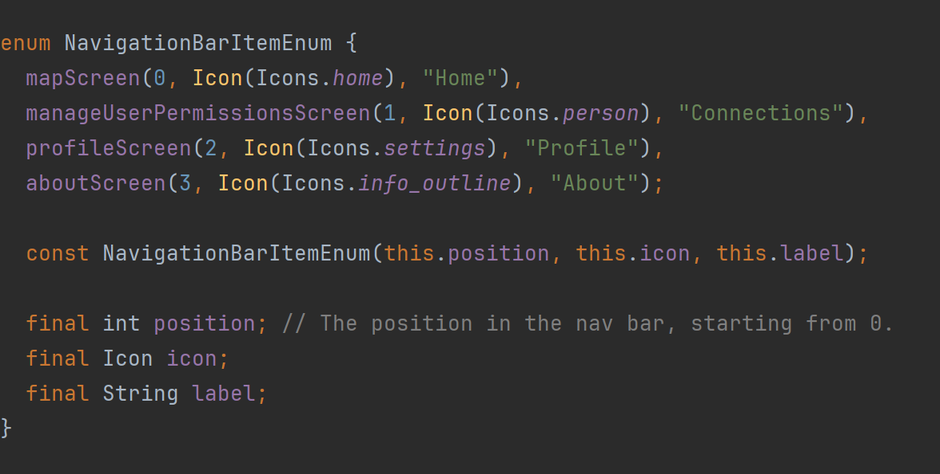

After adding the screen as an enum you then instantiate the screen within the constructor of NavigationBarItems and add the screen to the list of screens as shown below. The main screen then gets all the child screens from the NavigationBarItems class and automatically adds them to the navigation bar and makes it so that the screen appears when the user clicks on the icon for the screen from the navigation bar. This setup makes it very efficient to add new screens and allows the screens to be managed easily.

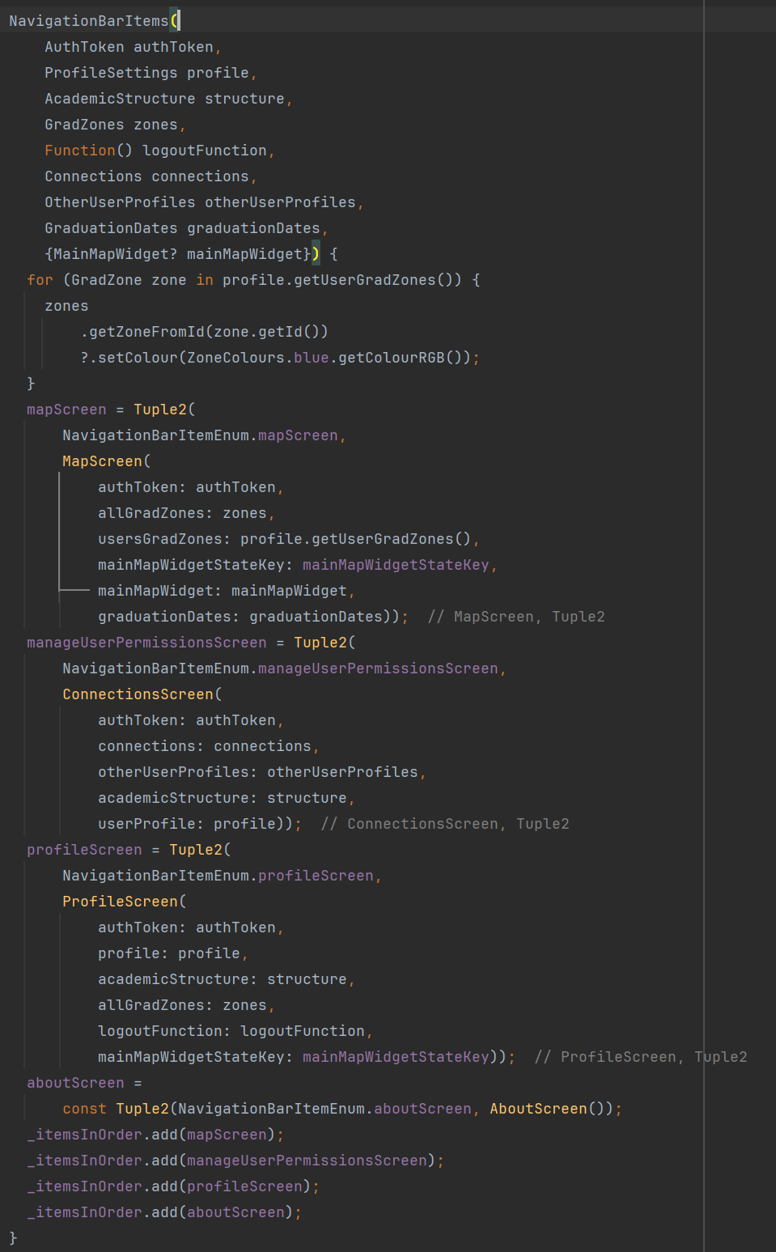

### Task 3 – Map Screen Creation

After this, the next task was to add the map screen to the application. I reused code I wrote for an earlier project here and so this was done quickly and efficiently. The MapScreen class creates the map widget and allows for other widgets to appear in the map screen apart from just the map.

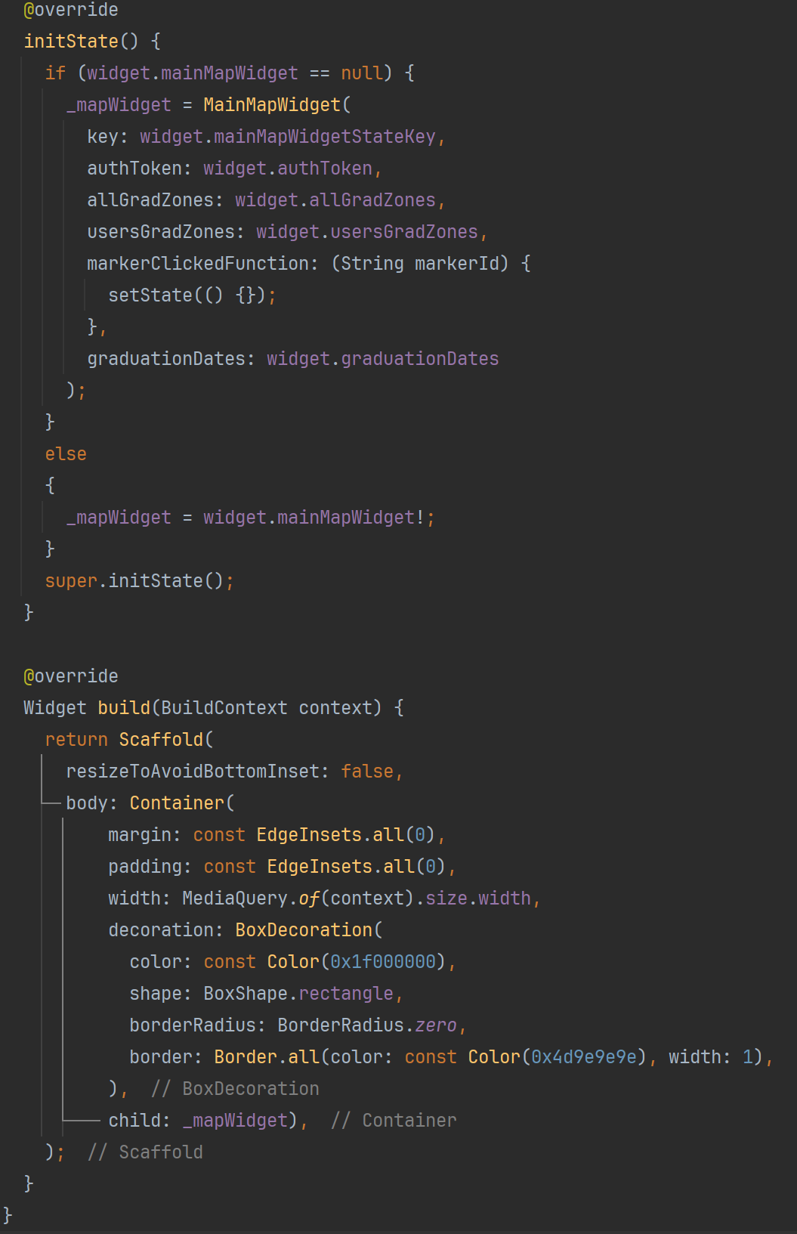

The MapWidget abstract class is used to interact with the OpenLayers JavaScript library. MapWidget loads the html file map.html which contains the JavaScript to interact with the OpenLayers API.

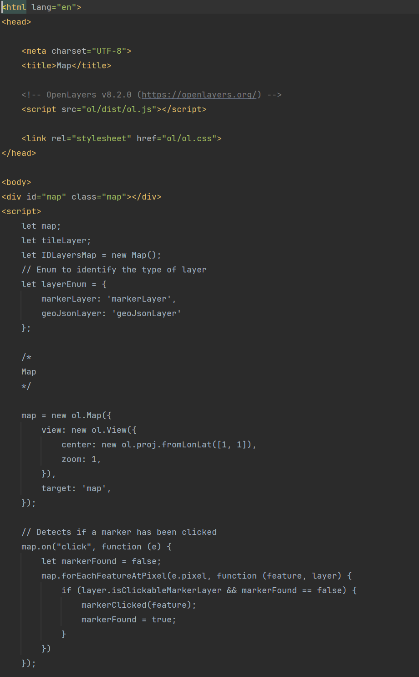

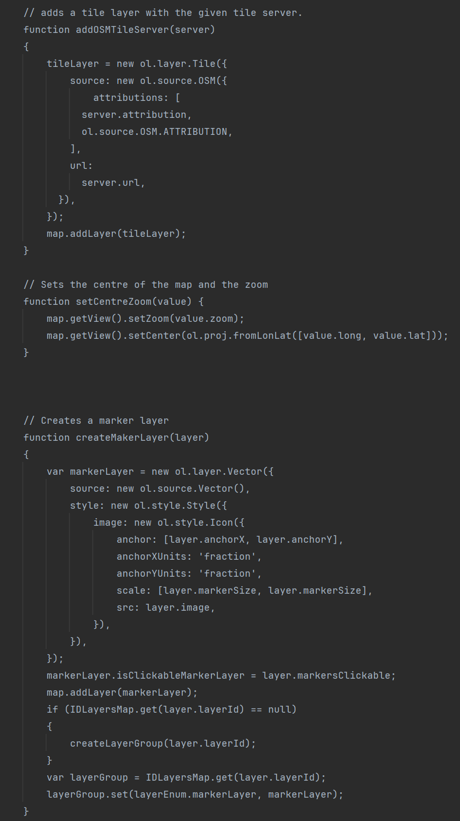

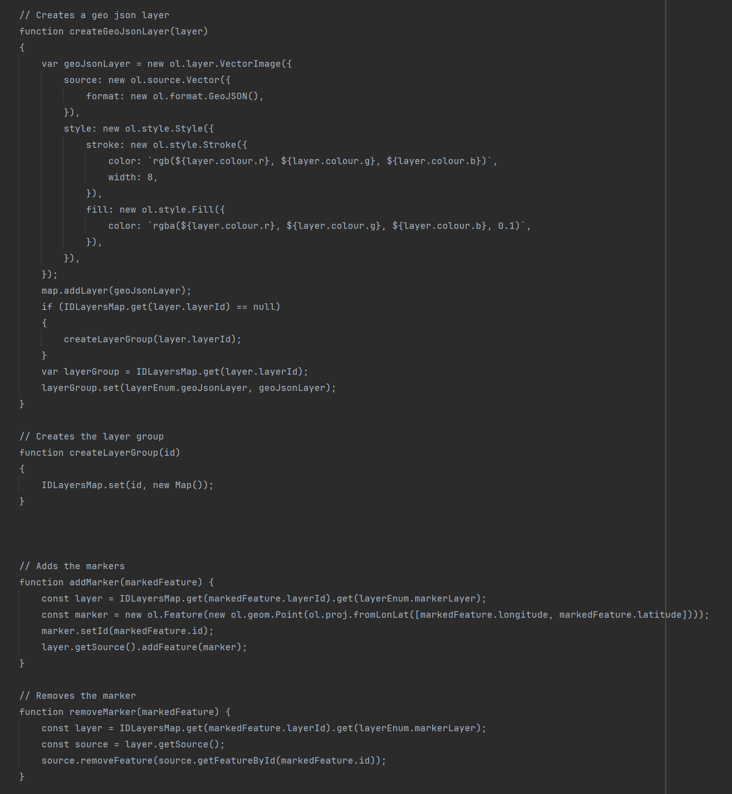

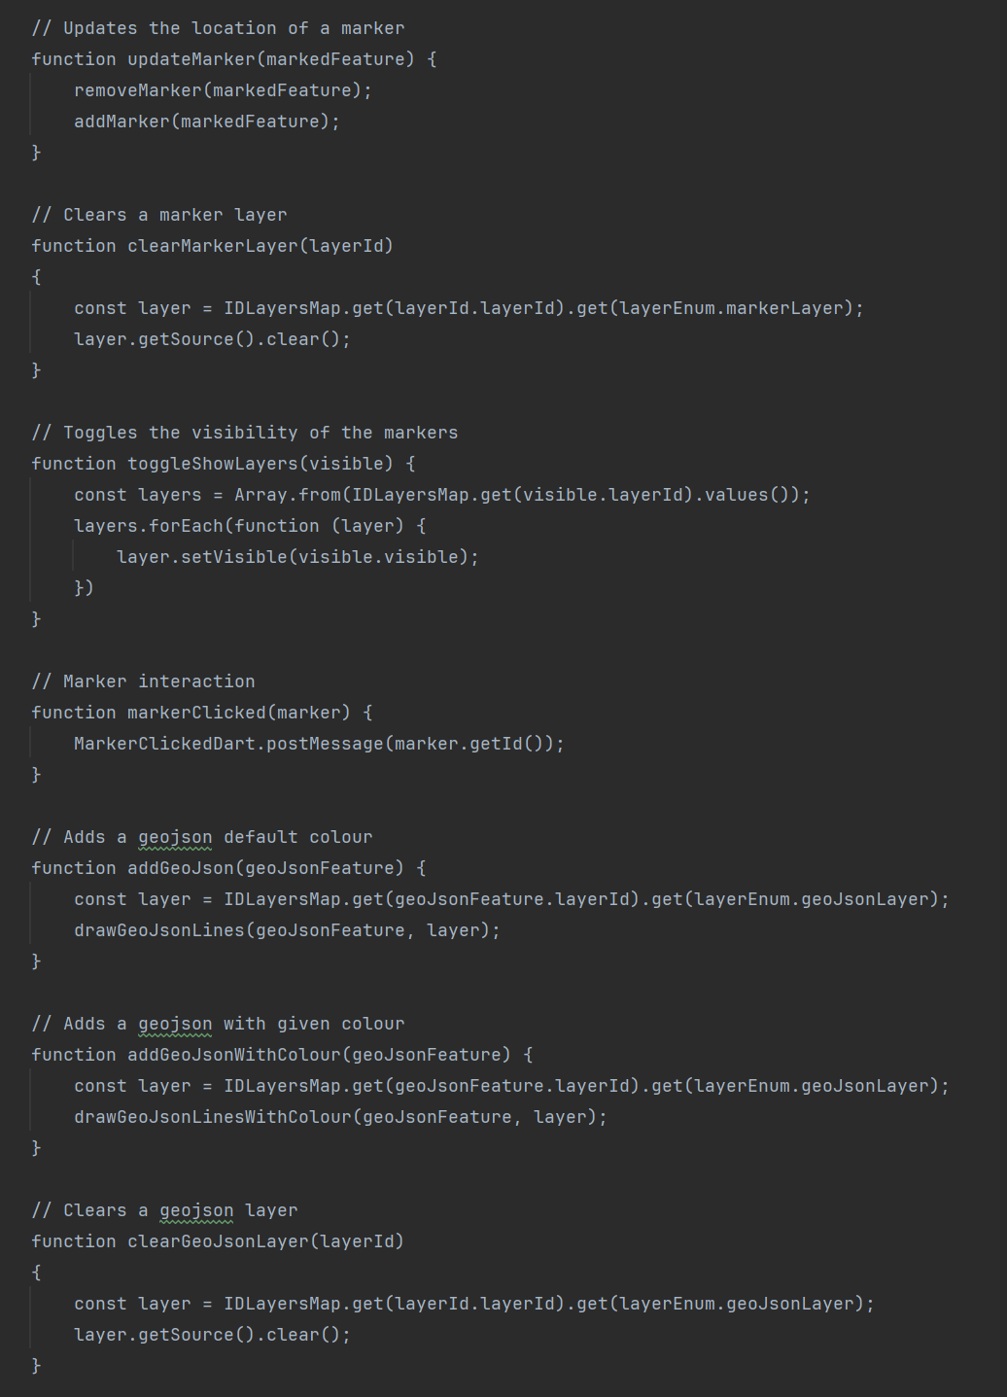

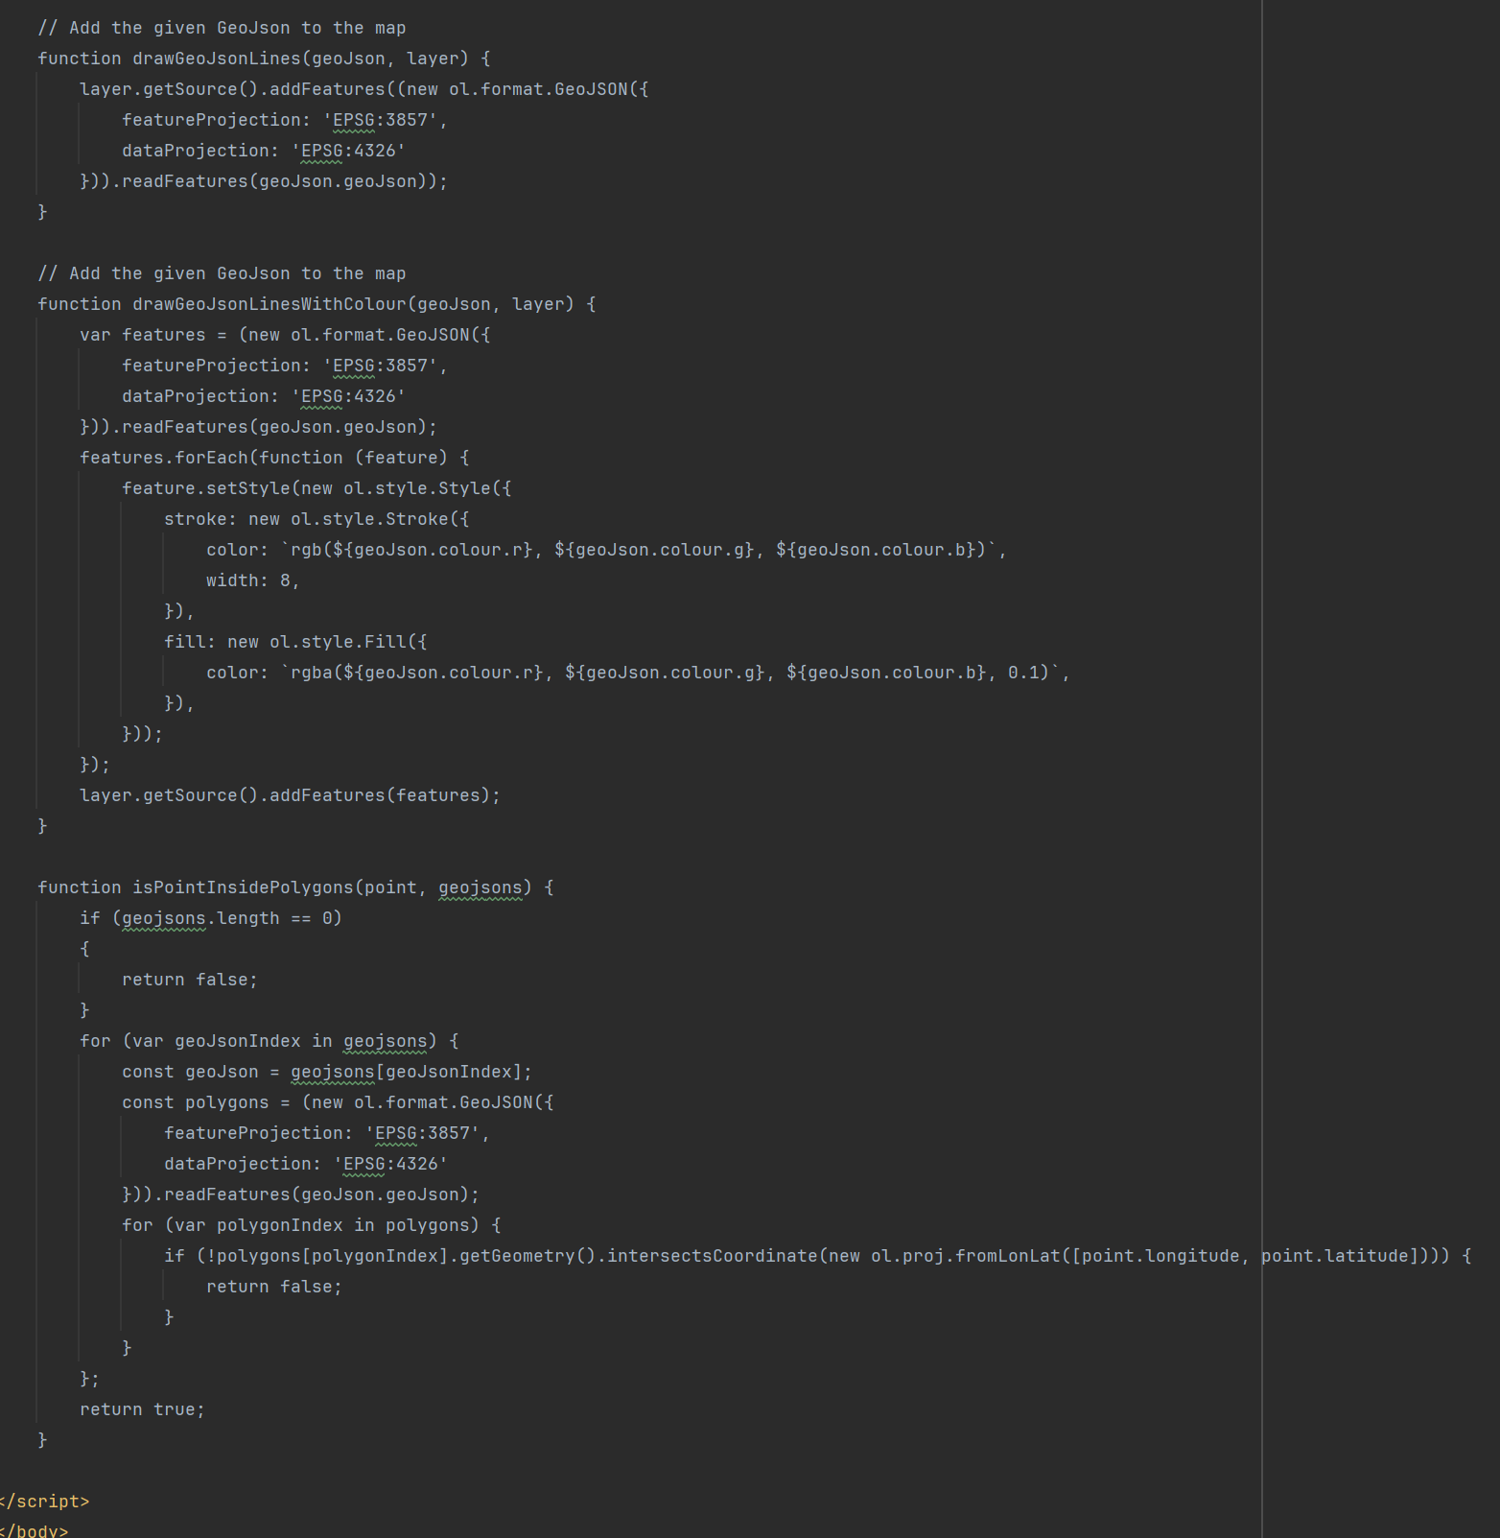

To render a map on the screen a child class must be created that extends MapWidget, this allows for multiple maps to be created within the application that might have different requirements, this is a feature that is not used within Graduation Gathering but was used in the project that this class was originally written for. For Graduation Gathering, the child class used to create the map is MainMapWidget. Whilst MapWidget, MainMapWidget and the html file called map.html were all originally used for a different project, they have been edited to better serve their purpose within Graduation Gathering.

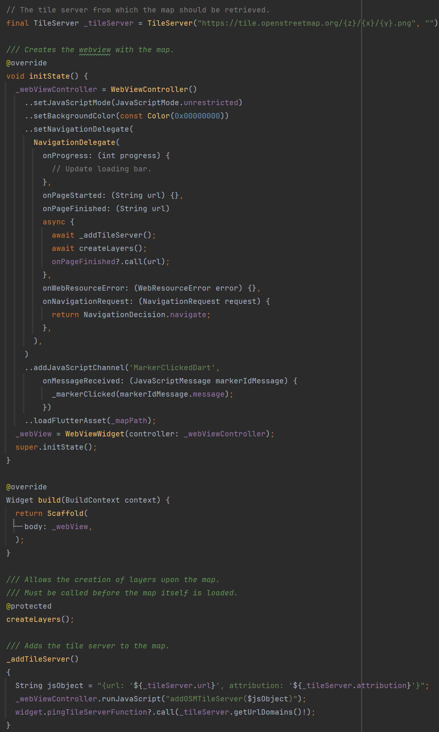

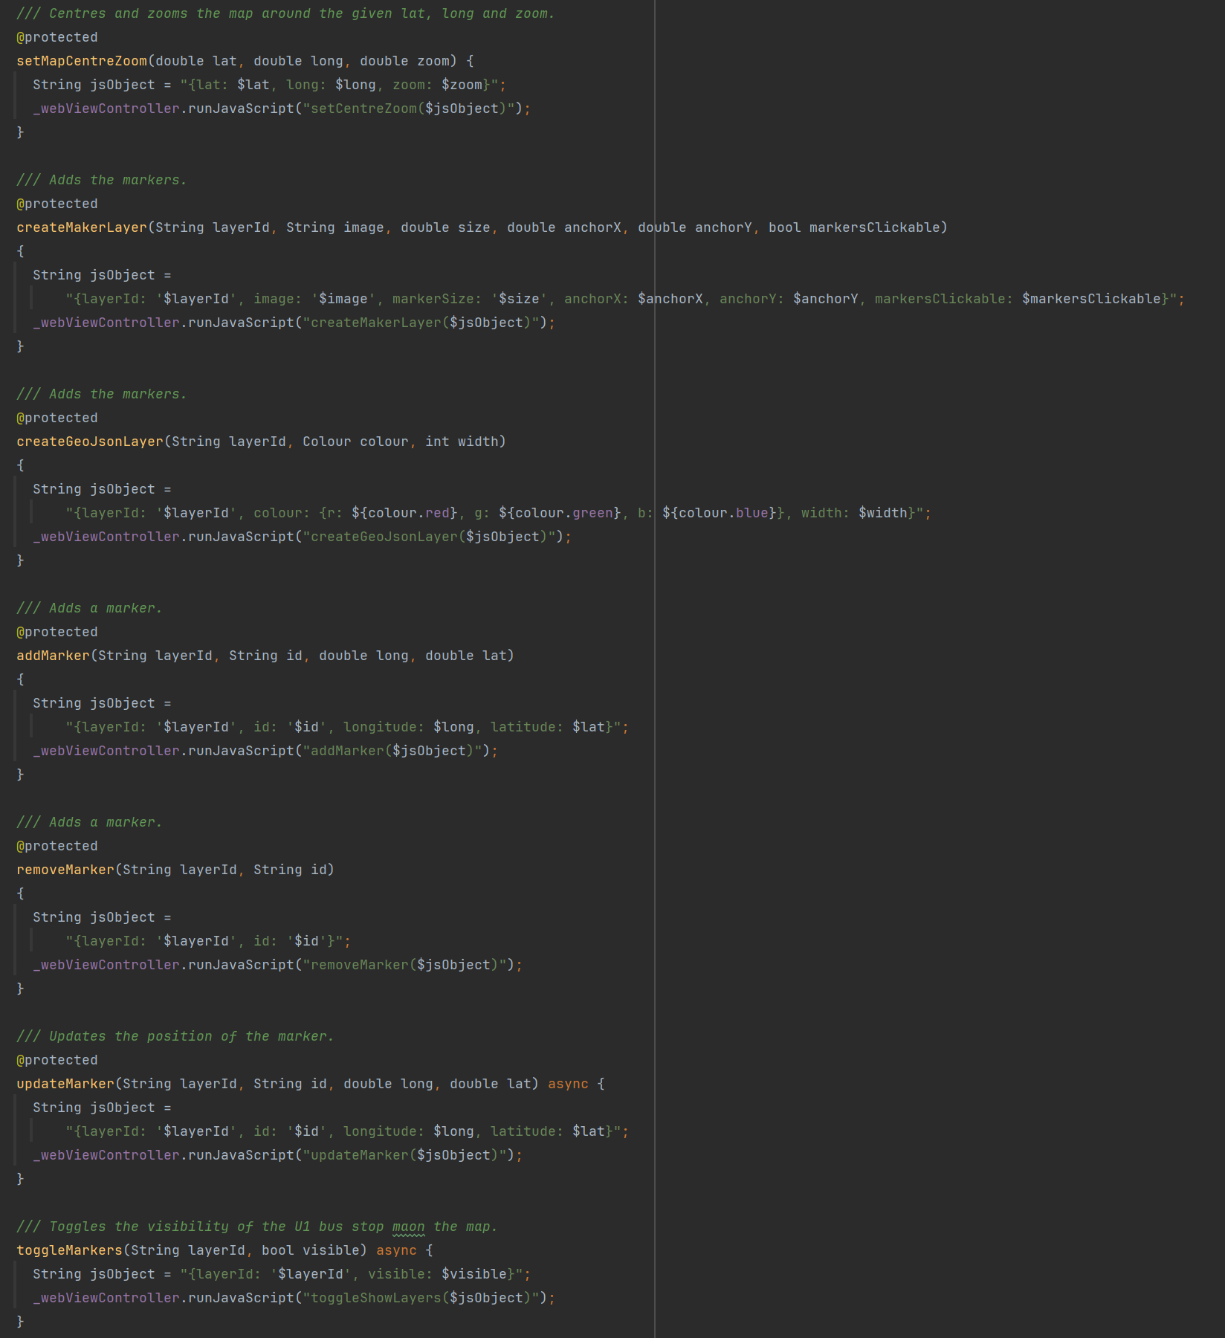

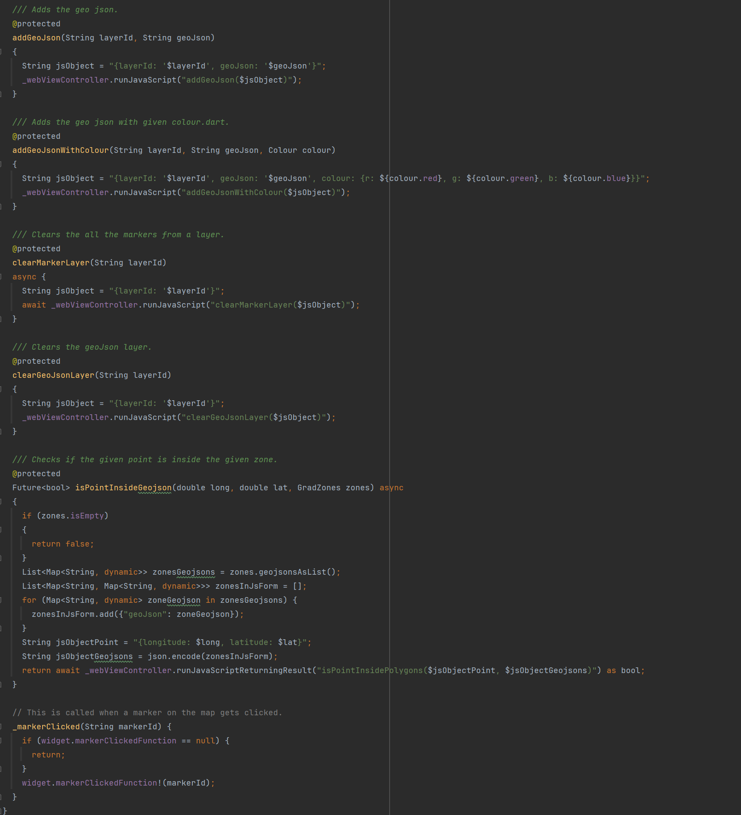

All communication between Dart and JavaScript is done within the MapWidget class, MainMapWidget only calls methods from MapWidget. This encapsulation simplifies the process of interacting with the map from the perspective of MainMapWidget and so makes it easier to add additional features.

The map is interacted with by adding layers that are rendered on top of the map, markers and shapes can then be added to these layers. To add a layer from the MainMapWidget class, you add a line to the createLayers() which calls either createMarkerLayer or createGeoJsonLayer from MapWidget. You must specify an ID for this layer that must be used whenever you want to interact with the layer later on. The layer ID’s on the Flutter side are stored in the MapDataId enum.

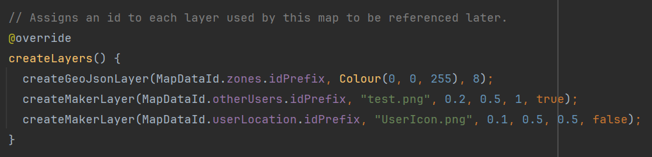

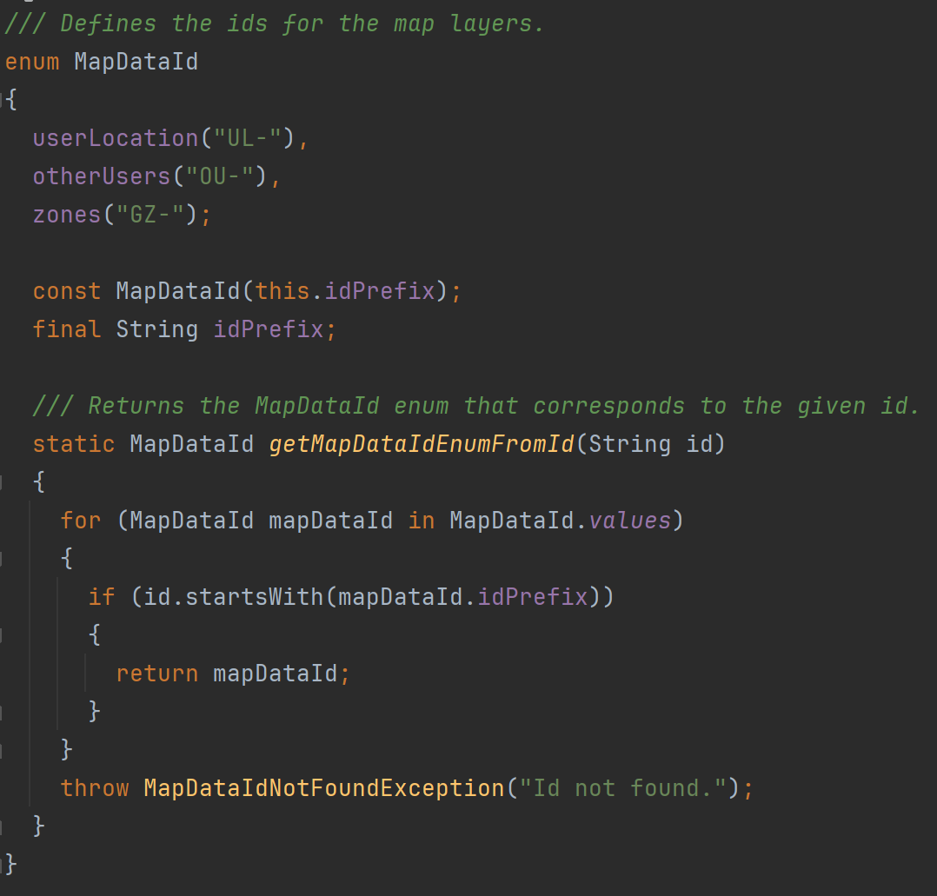

The user’s location is shown on the map through a marker. This marker is by adding a callback to the LocationHandler class. Whenever LocationHandler gets an update on users location, it then calls the method given to it by MainMapWidget. This method also sends a request to the server to update the user’s location for the other users of the app.

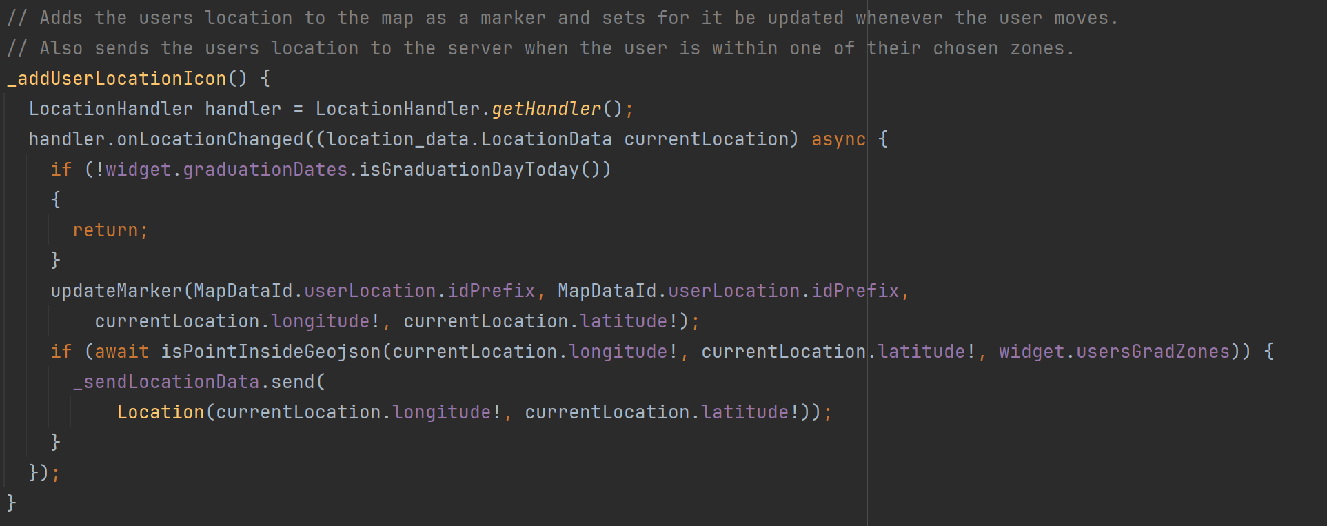

The locations of the other users that the current user has permission to see is updated by setting a repeated timer which fires every 10 seconds. It sends a request to the server asking for the other users locations and then loops through them adding each one to the map as a marker.

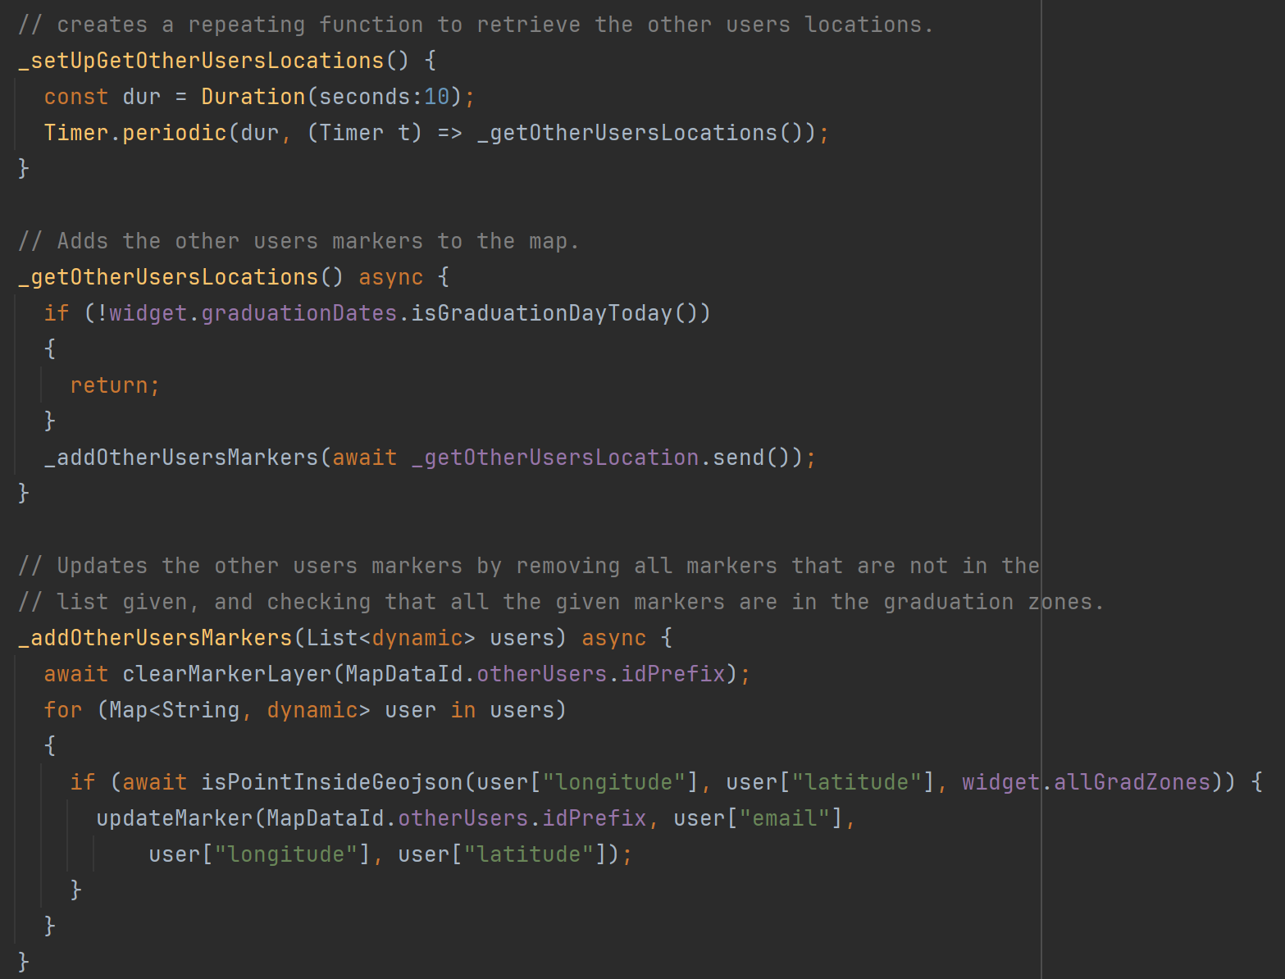

### Task 4 – Create Server and Framework For Calling the Servers Endpoints

Here I created the AWS RDS instance and the initial database schema. I also created initial AWS lambda methods to test the interaction with the database. These Lambda Methods are then exposed using AWS API Gateway.

The lambda method CreateAndAddToDatabase was created to manage the database schema as well as insert any data I needed to directly into the database. This method is not exposed by the API Gateway and can only be accessed using the AWS management console.

A blueprint for adding tables was created, for example see the SQL for the faculty table below.



Data could also be added directly to the database as shown below for the faculty table.



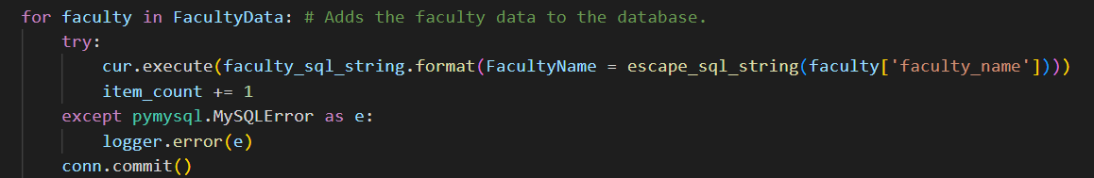

All lambda methods that access the database and interact with the database by giving it strings generated by the user contain a method to clean the string so that is cannot be exploited by these users through SQL injection attacks.

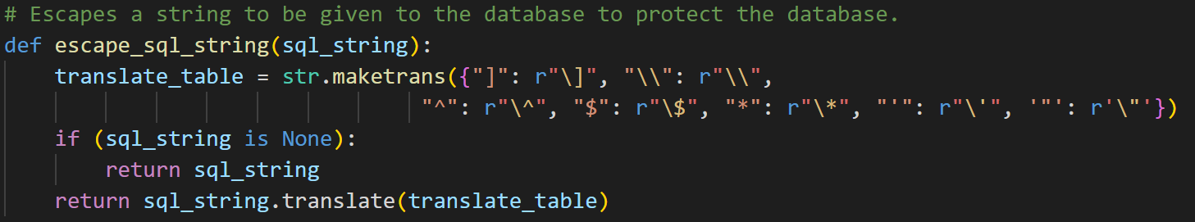

The main part of this task was to create a framework in Flutter for accessing the lambda methods in the server.

The design that I settled on is the SendRequest class which stores the server URL and has methods to send both GET and POST requests to the server. The way the system works is that, if you have an endpoint you want the Flutter app to reach, you create a child class of Send Request and in the getRoute() method that you must create, you return the route with the server to the endpoint that you want to hit. Then you create a method within this class that calls either post or get within SendRequest to actually send the request to the endpoint at the given route with the server. See below both SendRequest and SendLocationData as an example of how to extend SendRequest to hit a specific endpoint.

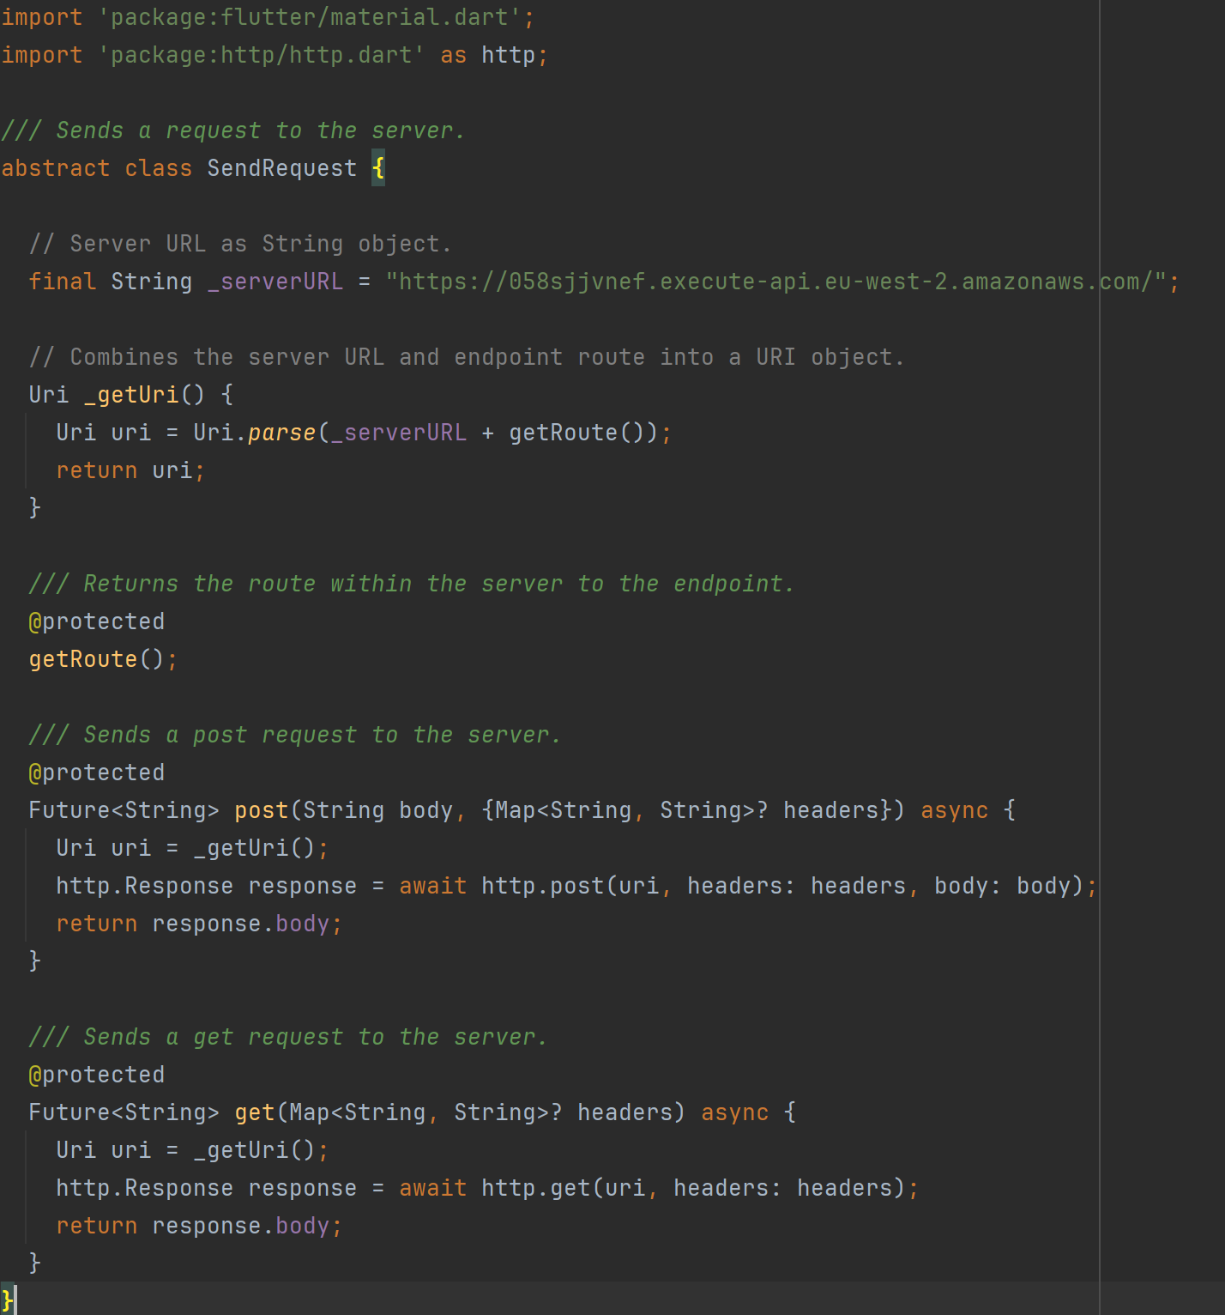

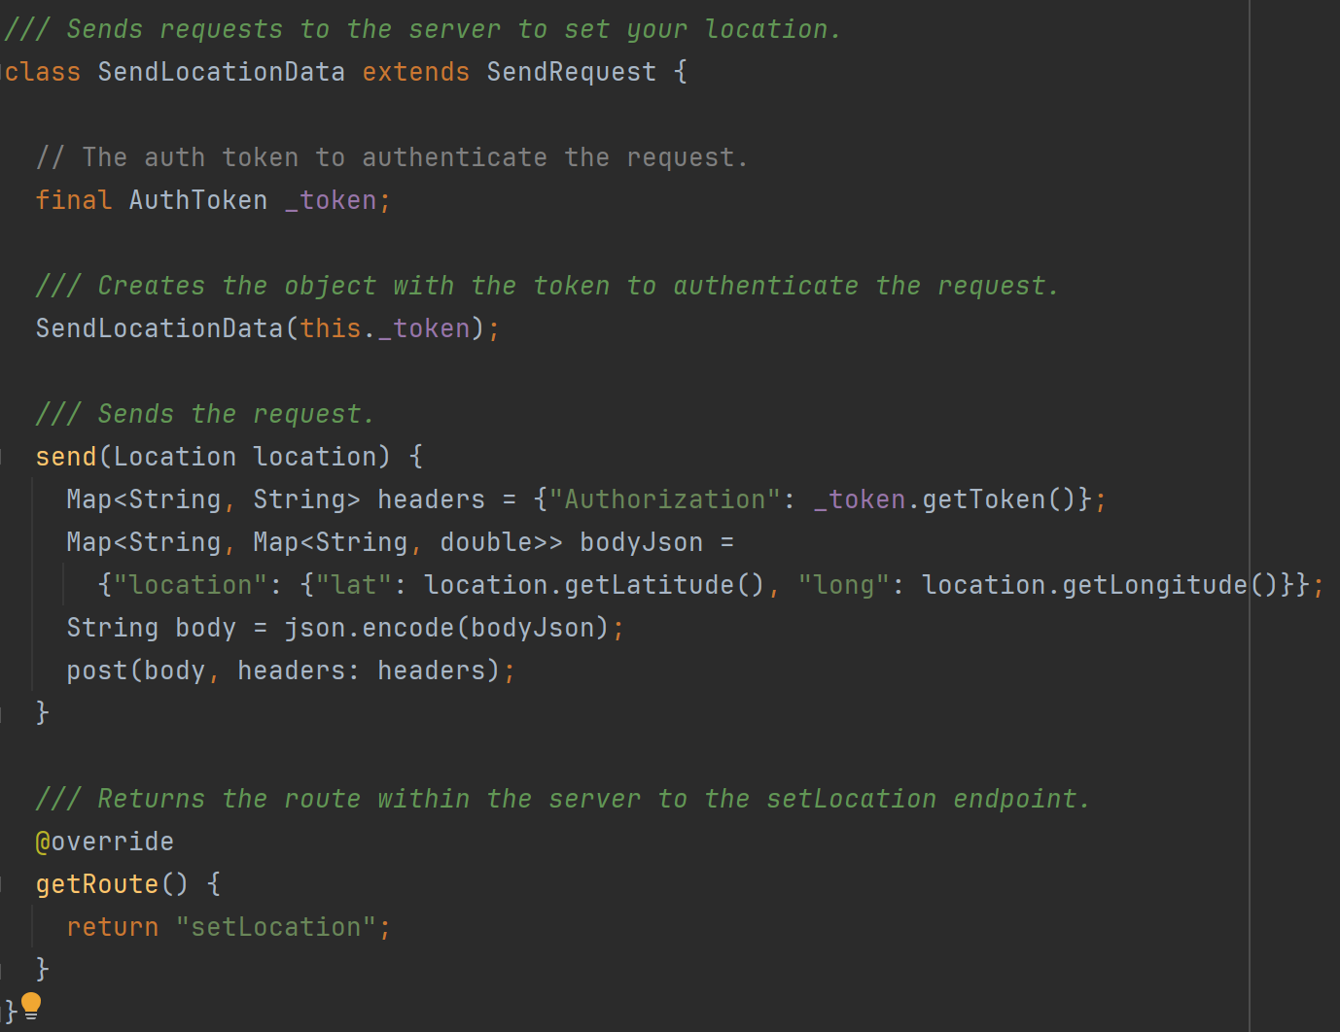

### Task 5 – Login and Authentication

To secure the server from unauthorised access, JWTs (Json Web Tokens) are used to authenticate every request to the server that is not used to login. AWS API Gateway makes it very easy to attach a lambda method that authenticates requests to be called before the exposed endpoint. Using this feature I created the Auth lambda method which is given a JWT and checks if the signature is valid (thus was created using the encryption key only the server has access to) and if the time on the token has not expired.

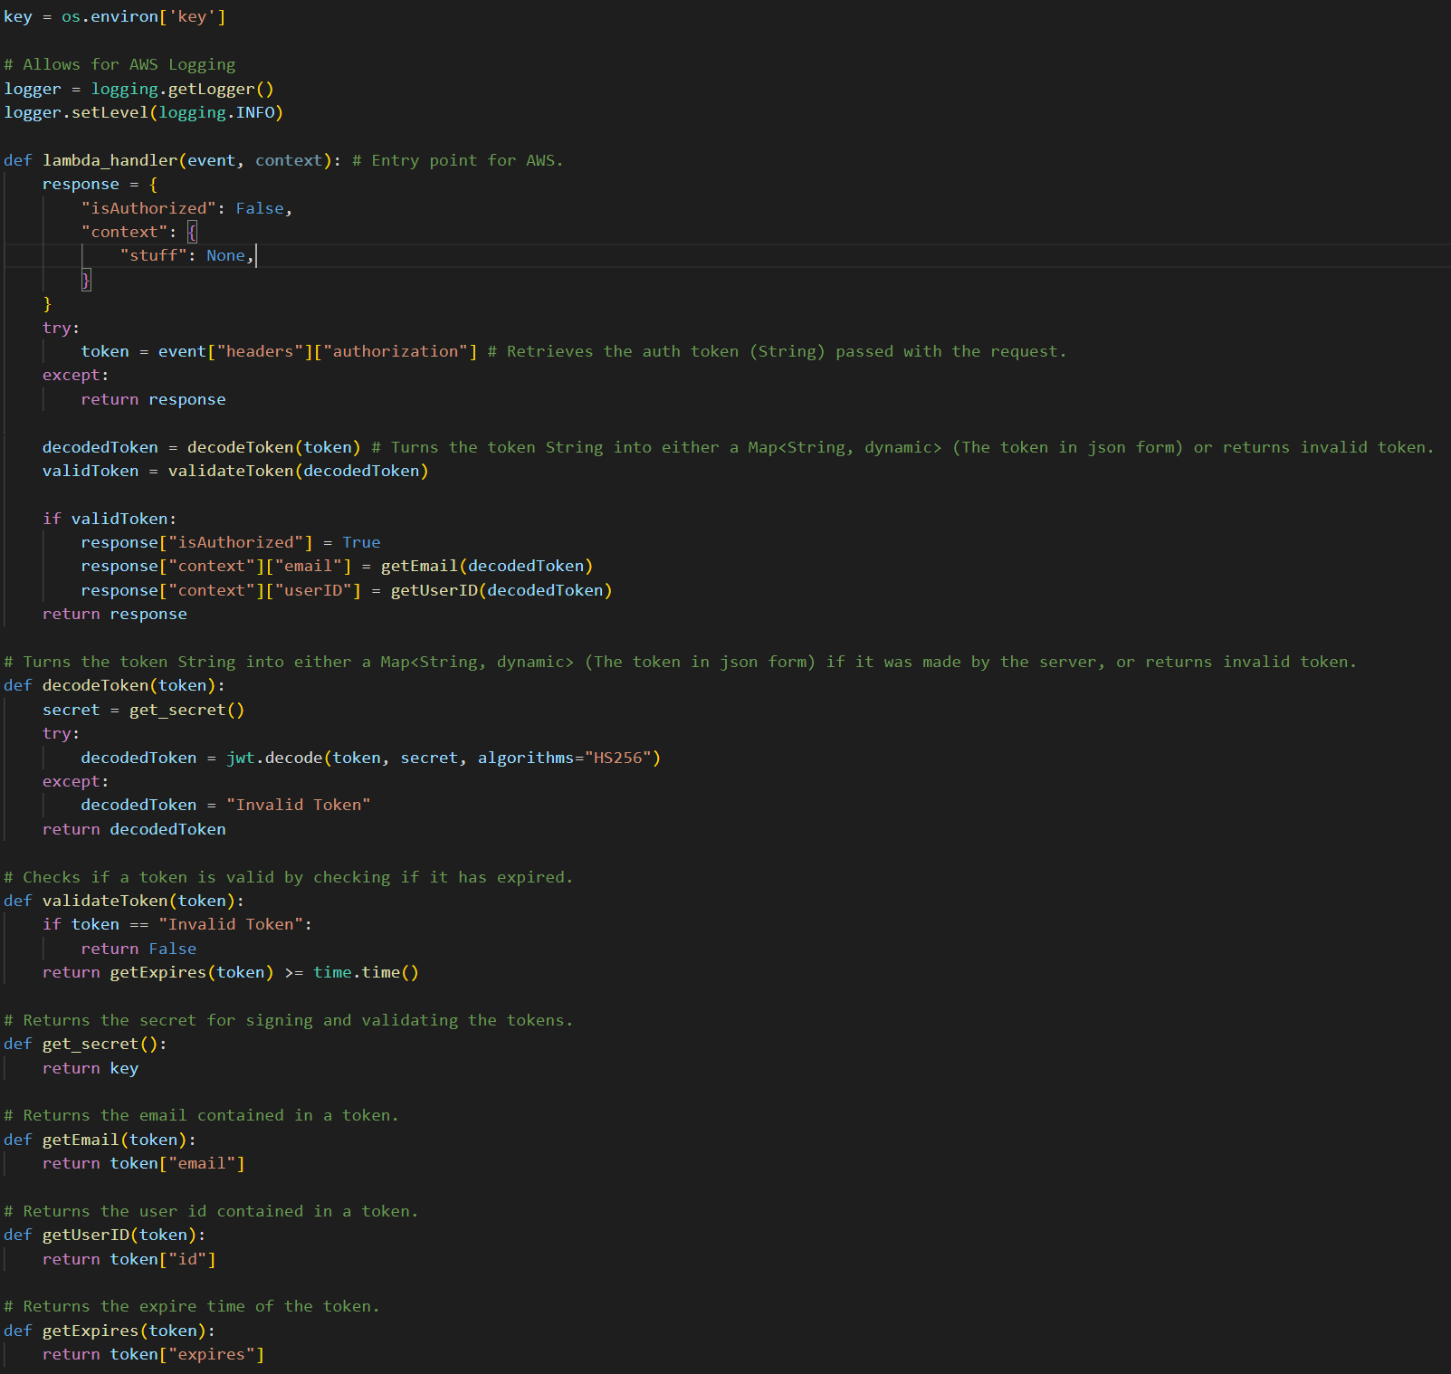

Users must also be able to obtain these tokens when they login. So I created a login screen in Flutter that allows users to enter their University of Portsmouth email. This screen is coloured in the light blue colour of the University of Portsmouth.

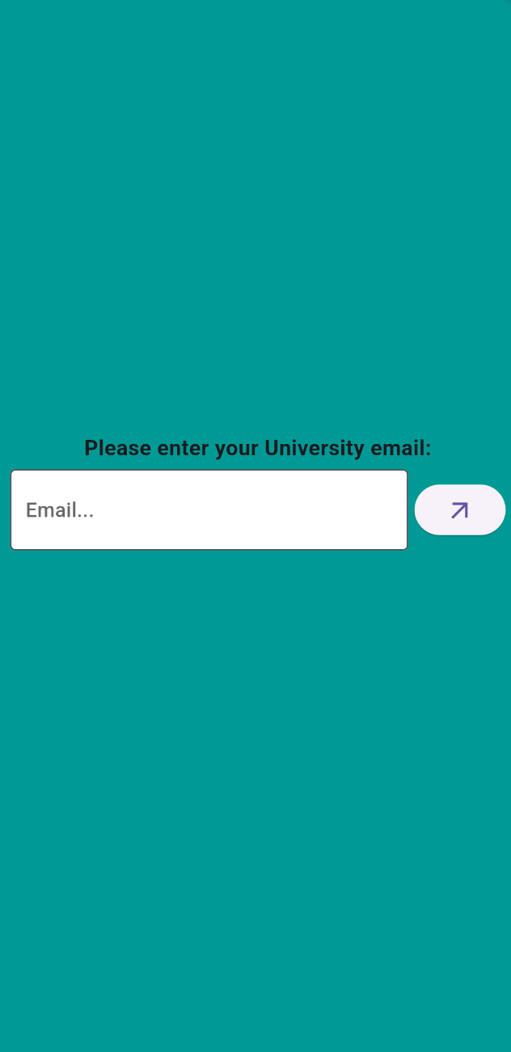

This email is parsed to check if it is a valid University of Portsmouth email. This is done in the ParseEmail class which uses a regular expression.

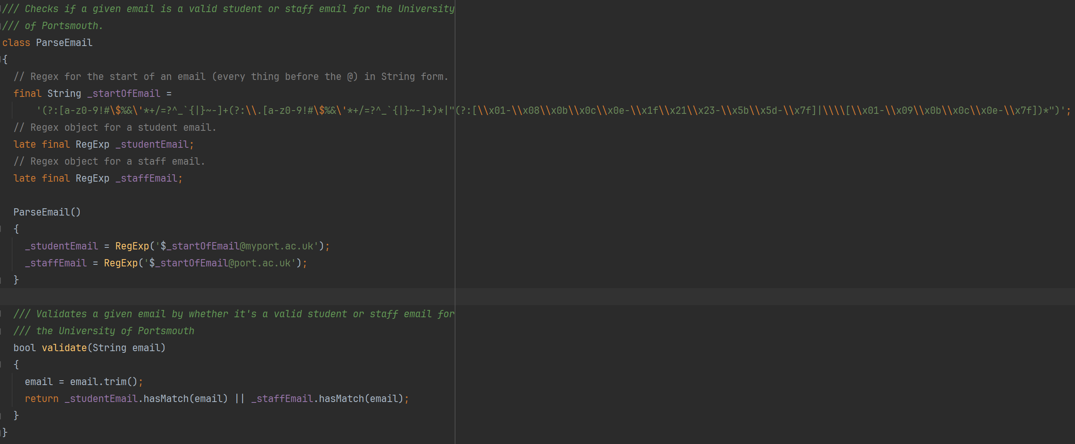

If the email fails the parse then the screen asks again for an email from the University of Portsmouth.

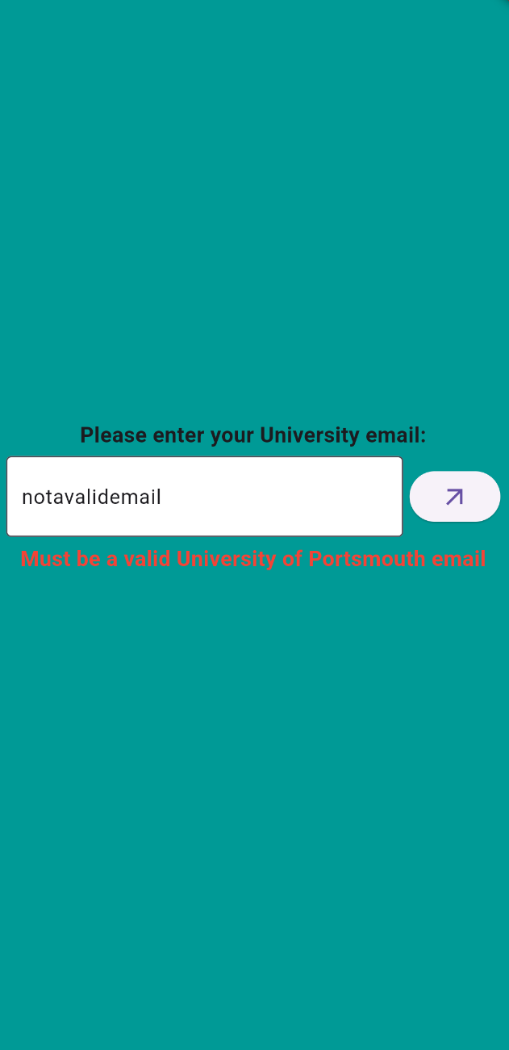

If the email passes the parse, then this email is then sent to the SendEmailCode lambda method. This lambda method checks if the email is a valid University of Portsmouth email, then checks if an account for this email exists in the database, if not then it creates an entry in the database for this email, then creates a login code for the account and saves that to the database, then sends a request to AWS SES (Simple Email Service) to send the login code in an email to the email address given.

To check if the email is valid, it uses the same regular expression as the Flutter App. This check is done on the client side to stop unnecessary requests being sent to the server, and its done on the server side for security so people cannot call the endpoint directly outside of the Flutter App and enter any email address they want.



Accounts are checked if they exist by trying to find the userID from the entry with the given email. This is the primary key in the database.

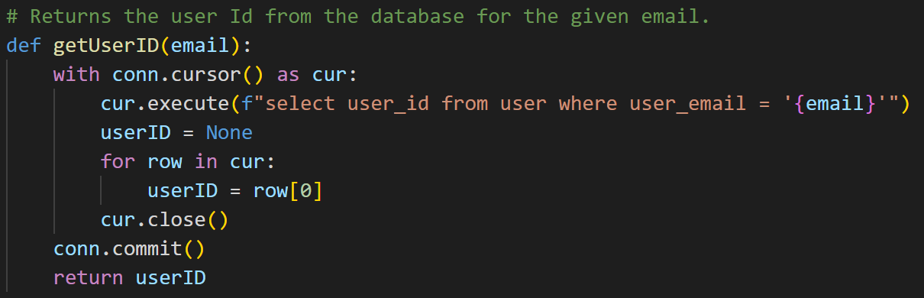

If no user ID is found then a new unique user ID is generated for this email. It is a code that starts with “US-“ short for user, and then is followed by 10 digits. It is guaranteed to be unique by then checking if the generated user ID already exists in the database, if it does then a new user ID is generated.

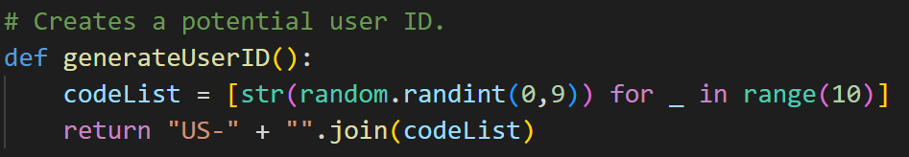

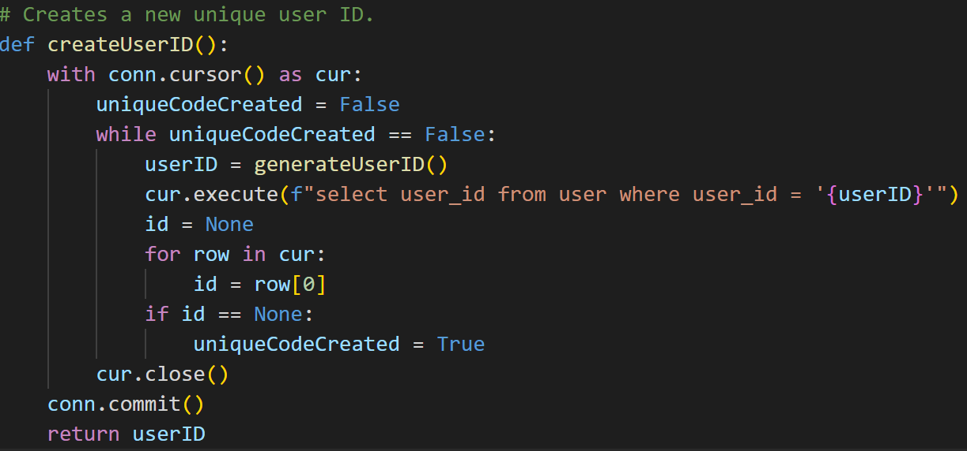

Next a login code is generated for the user, this is just a 5 digit number padded at the front with 0’s to always be 5 digits long.



The code is also given an expiration time as 5 minutes from the current time. This is done by getting the seconds since the Unix epoch and adding 5 minutes’ worth of seconds (5 * 60 = 300).



Then the code and expiration time is written to the database, if an account for this email does not exist then the user ID generated and the email are also written to the database.

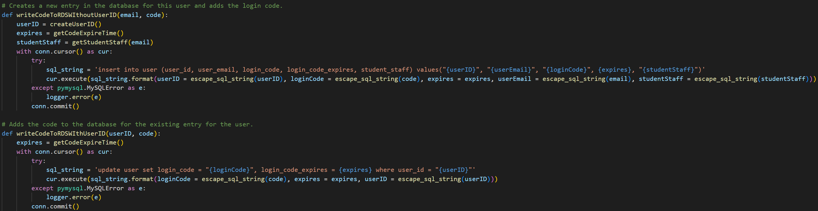

Finally an email is sent to the given email address with the code generated.

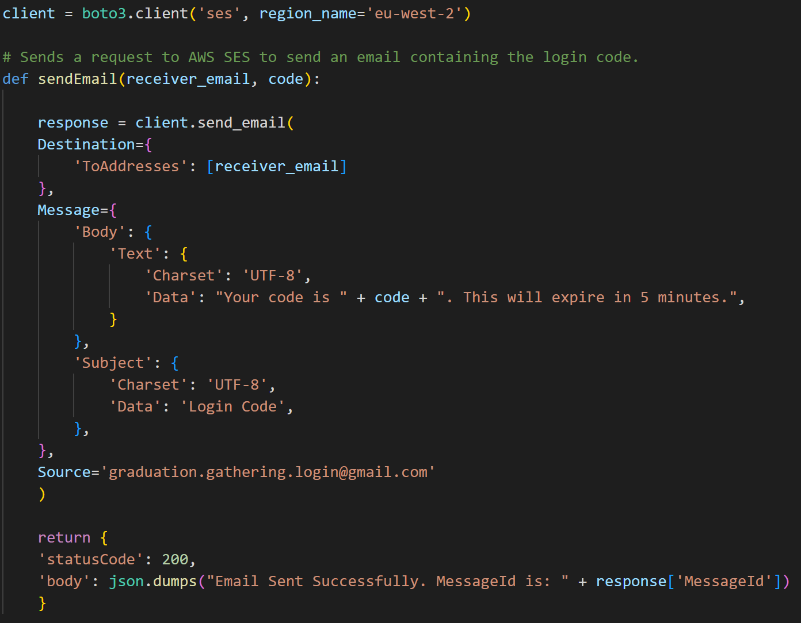

Now that an email has been entered, a code generated, and an email containing the code has been sent to the entered email, the user is asked to enter the code.

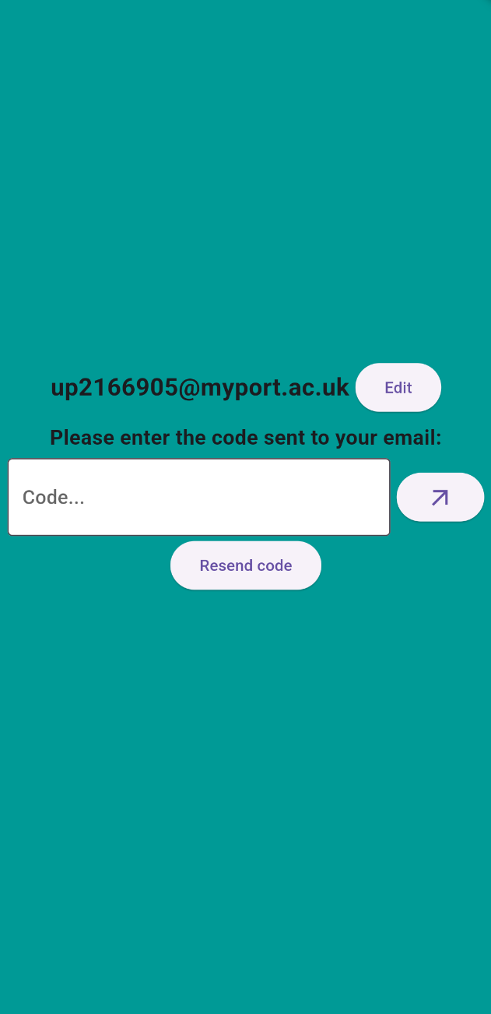

The code entered is then sent along with the email to the ValidateCode lambda method. This then verifies if the code has been entered by retrieving the login code and expiration time for the given email from the database.

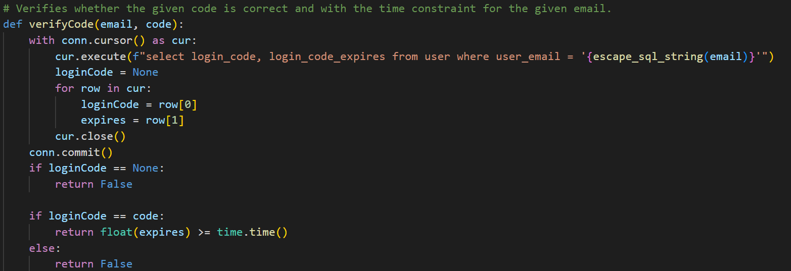

If the codes match and the time hasn’t expired then the user ID for that email is retrieved from the database and a JWT is generated using the user ID and email, and is signed using a key stored on the server. This JWT is also given an expiration date of 24 hours from its creation.

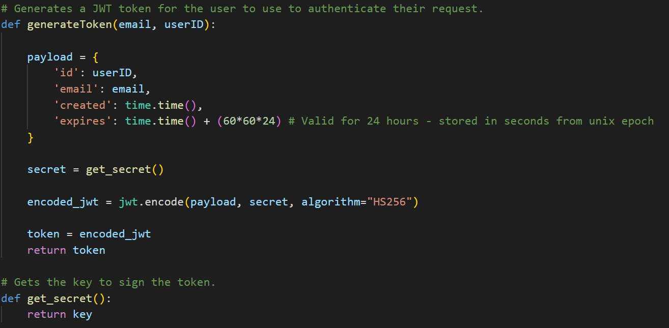

The last stage is for this JWT to be returned to the user and for the Flutter app to store it in secure storage so that it can be used to automatically login the user subsequent times the user logins until the token expires. The JWT is stored securely in the TokenStorage class using the FlutterSecureStorage package.

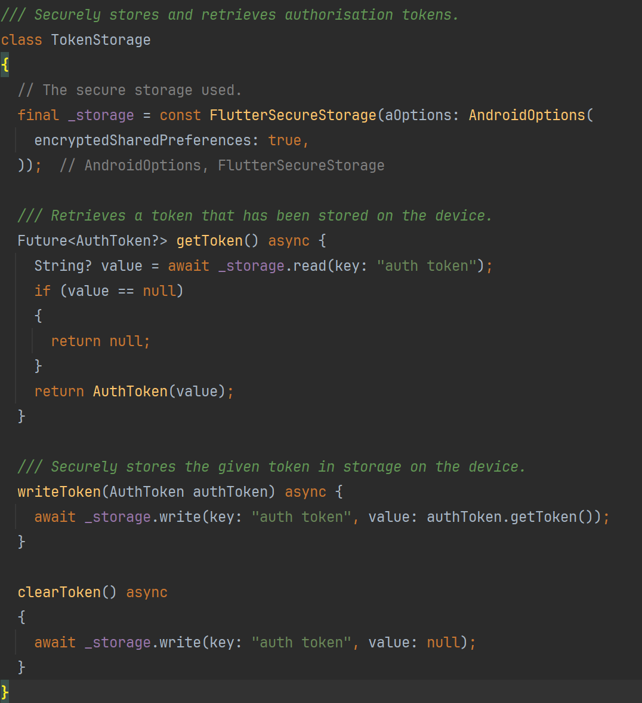

### Sprint 1 Summary

At the end of the first sprint, a Flutter app has been created with a login screen, a main screen with a working navigation bar, a map screen that displayed both a map and the user’s location. The server was also set up with a framework to easily add and call additional lambda methods and increase the capabilities of the database. This is a great jumping off point for the rest of the project and allows for the rest of work to be completed efficiently.

## Sprint 2 – Server-side API, Lambda Methods and Database Development

The goal of the second sprint was to develop the lambda methods and database to support the front-end that would be implemented later. The idea behind implementing all the lambda methods together instead of implementing a single method and then going and implementing the front-end for that feature, is that focusing on the lambda methods will keep them fresh in my mind and so allow me to work efficiently and effectively instead of having to refresh myself on how they work every time I want to implement a new method.

### Task 1 – Location Sharing

The first task is to implement the key feature of this project, location-sharing. This is done by having one lambda method which a user sends its location to, and a second lambda method which the user will get the other users locations from. These requests are done separately because the users location on the server should be updated every time the app receives an update of the users location, however, if the users location on the app isn’t getting frequent updates then if these requests were done together then the user wouldn’t get frequent updates on other users locations. This approach unties the user getting location updates of other users from their own location being updated.

The user’s location is updated on the server using the SetLocation lambda method. First the date is checked to see if it is a graduation day (8 am – 1 am next day), as location sharing is only enabled on graduation days. In reality this aspect was implemented at the end of development to make testing easier.

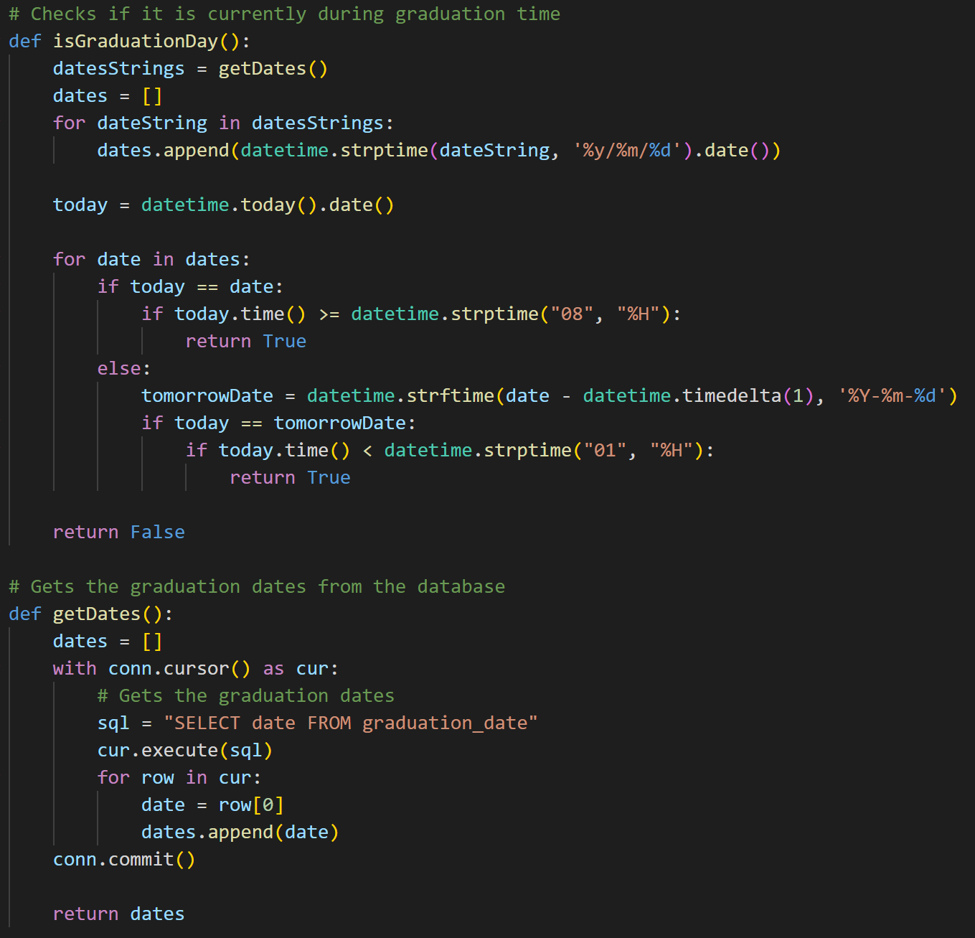

Then the location is simply inserted into the user’s entry using the userID taken from the JWT used to authenticate this request. The time that the location is set is also recorded so that once it is outdated information it isn’t sent out to users anymore.

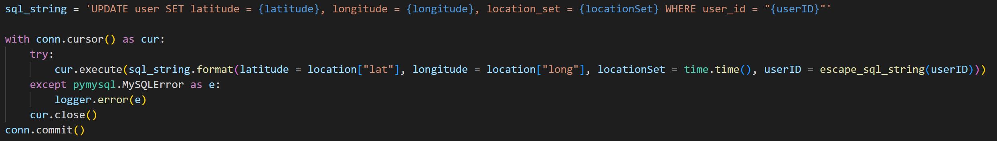

The locations of other users are retrieved using the GetOthersLocations lambda method. First it checks if it is graduation day, if so then it returns all the profile information and location of every user that this user has permission to see and that has set their location within the past minute.

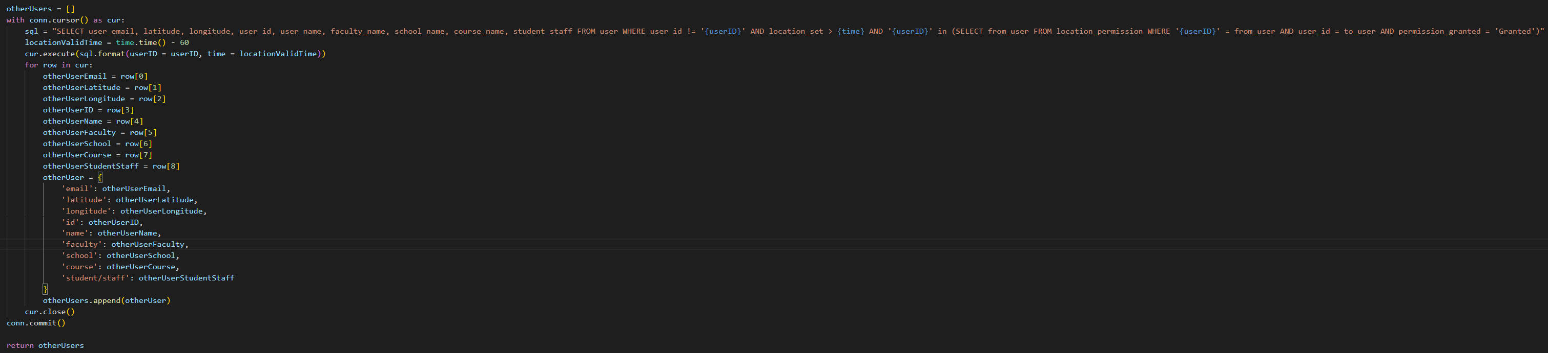

### Task 2 – Profiles

The second task was to store user profile information and allow it to be retrieved from other users. Users edit their own profile using the SetUserProfile and GetUserProfile lambda methods.

GetUserProfile is very simple, it just returns all the information on the user with the userID given by the JWT, this means that this information is only accessible to the user that the information is about.

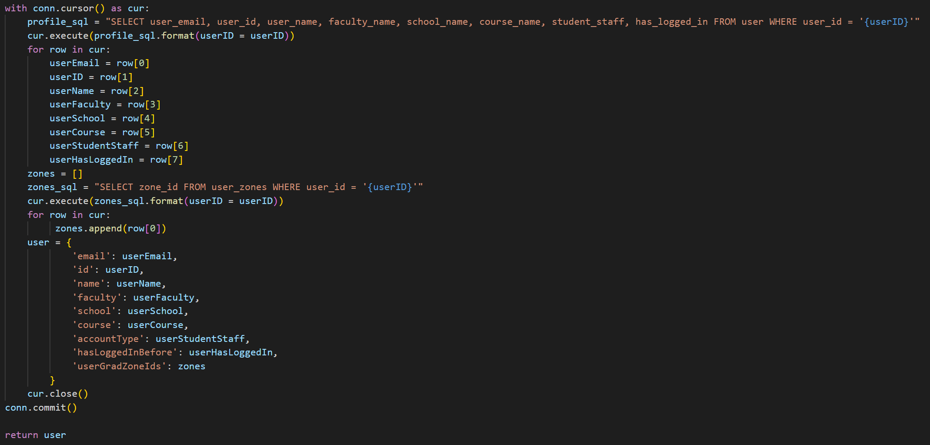

SetUserProfile allows a user to edit their own profile. It parses the input and sets any null data to “NULL”, then inserts it all into the database tables user and user_zones.

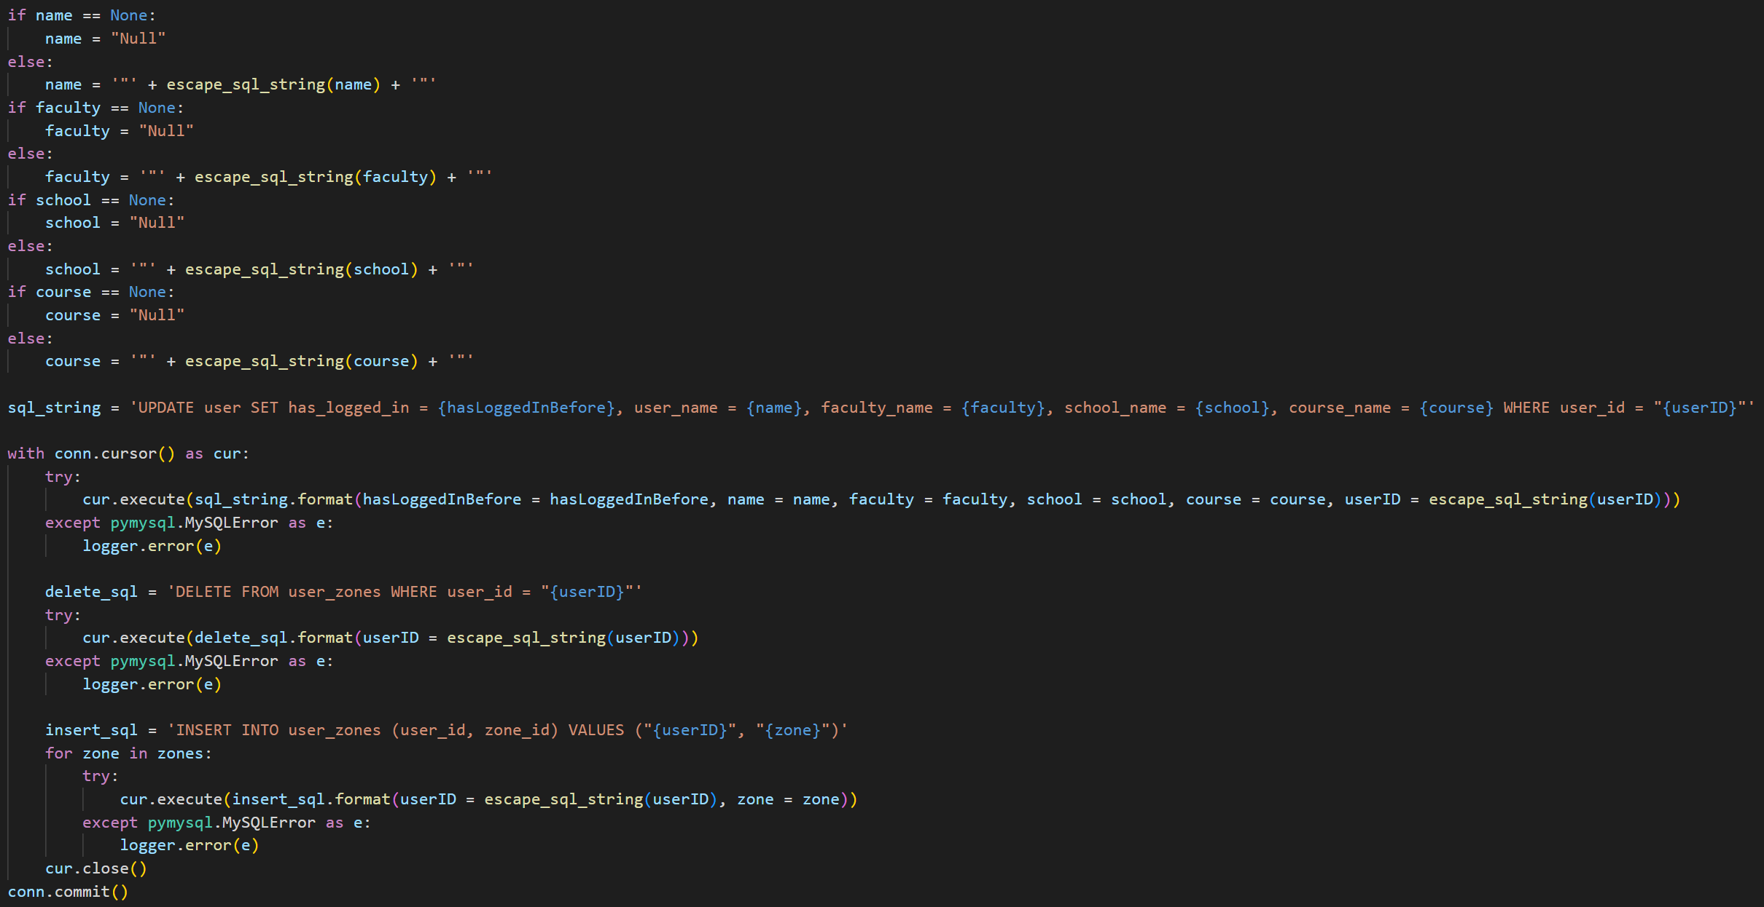

The methods allow the user to edit their faculty, school, course and graduation zones. However, at the moment there is no way for the user to retrieve the possible faculties, schools, courses and graduation zones.

The lambda method AcademicStructure gets the faculties, schools and courses.

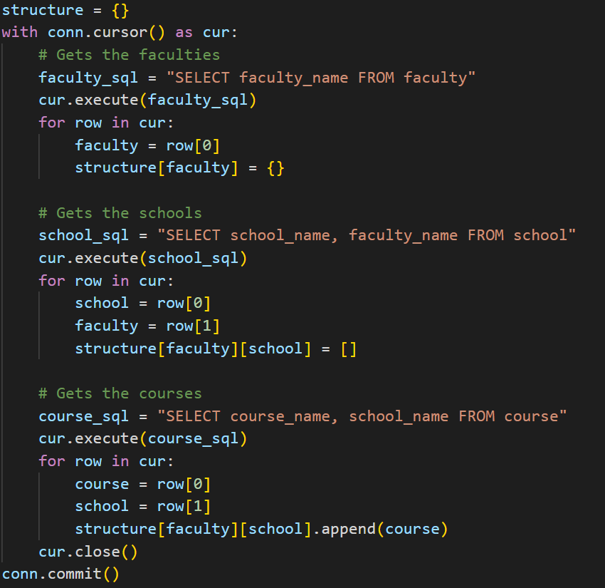

The lambda method GetGradZones returns the graduation zones. It gets the zones IDs, names and geojsons.

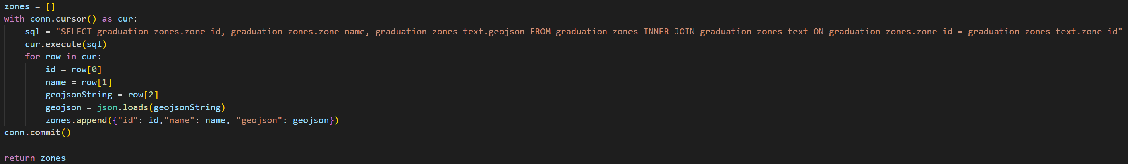

Finally, a user needs to be able to see the profiles of other users. This is done with the user of the lambda method GetAllOtherUsersProfiles which gets the user ID, email, name, faculty, school, course, and account type of every single other user that has verified their email address.

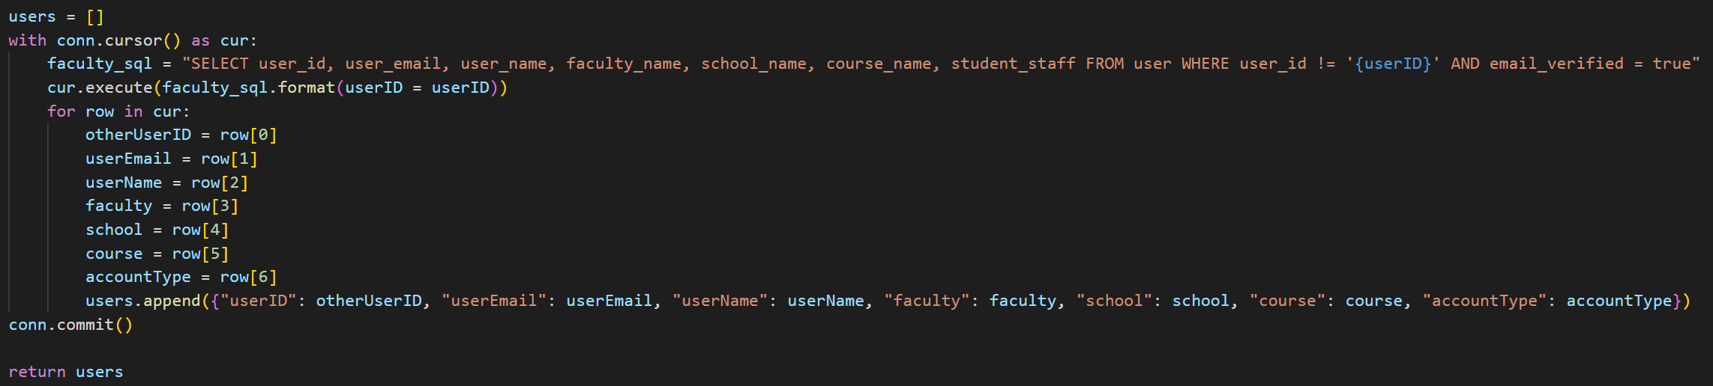

### Task 3 - Connections

The only part of the server now missing is the ability to request and grant permission to see other people’s locations. First, GetConnections returns all the connections that a given user has, this is both granted and requested permission, and both for this user to see other users and for other users to see this user.

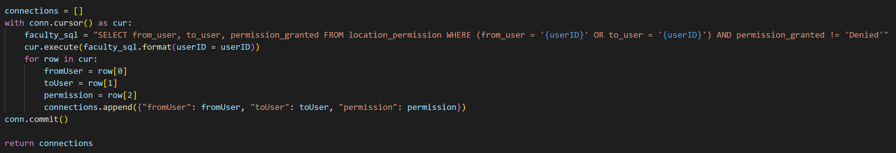

Finally we have the four lambda methods for managing connections:

SendConnectionRequest for requesting permission from another user to see them.

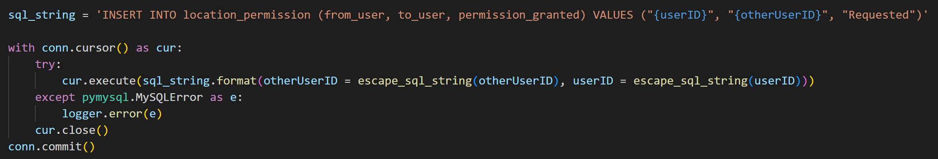

GrantFollowerRequest for granting permission to another user to see you.

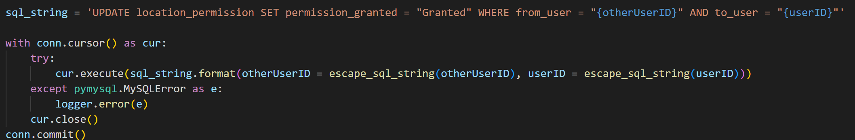

RemoveFollowingRequest for deleting your request for permission to see another user.

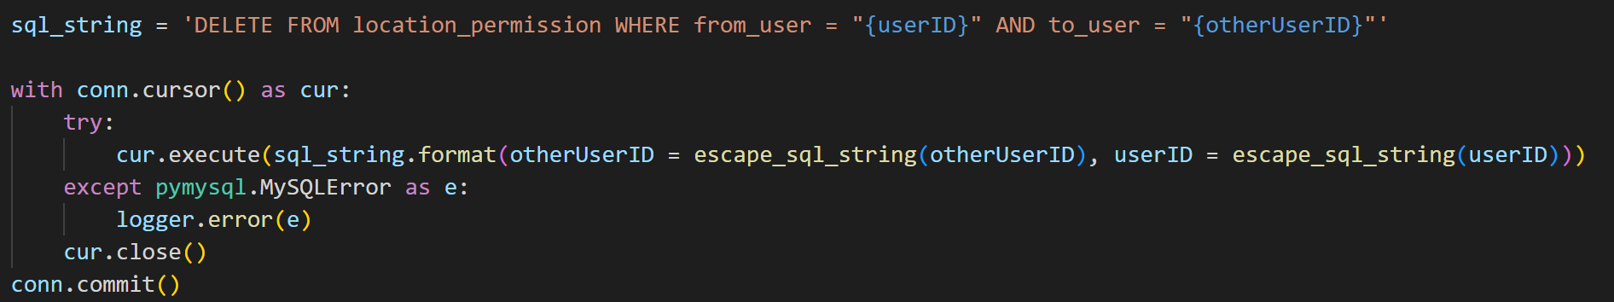

RemoveFollowerRequest for denying another user permission to see you.

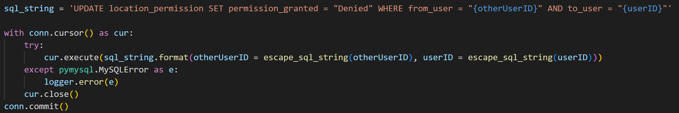

### Sprint 2 Summary

The server-side of the application is now in a near complete state, further editing would be done in later sprints as the design changes, but apart from these minor changes to server is done. Now the app itself can be built and focused on.

## Sprint 3 – UI and Front-end Logic

Sprint 3 is the final sprint, during which the UI and the logic to support it was built. This sprint provided a chance to evaluate the whole working product.

### Task 1 – Graduation Zones

The graduation zones are the areas of Portsmouth where a user’s location can be shared. A zone is coloured blue on a user’s map if they will appear within it, and red if they will not appear within it.

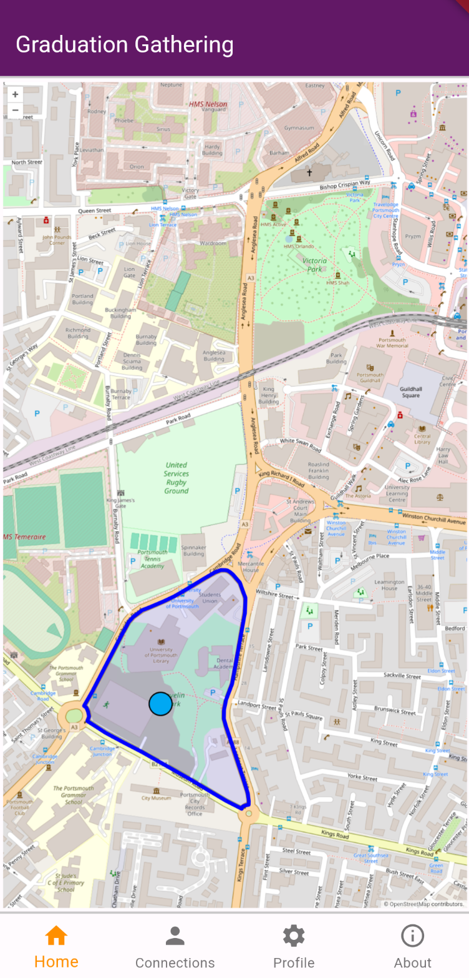 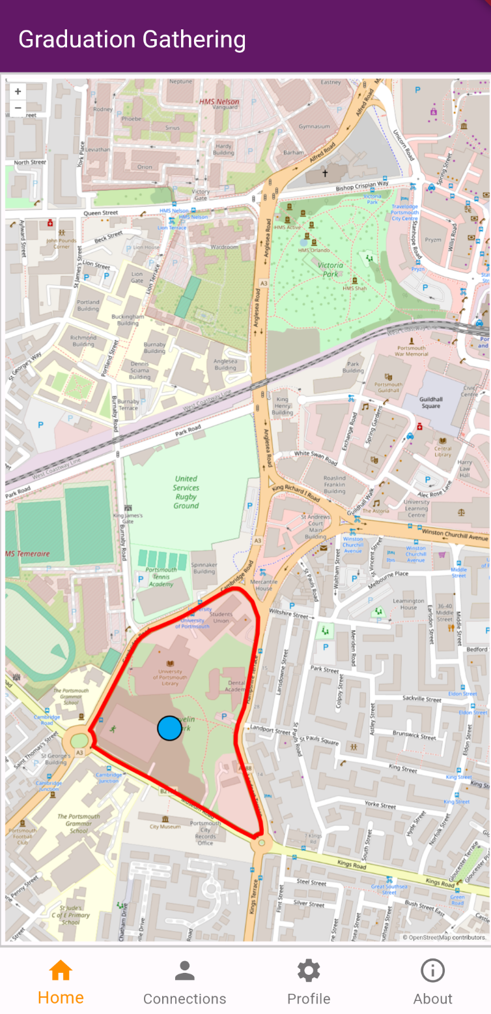

The zones are stored in the database as geojsons. These geojsons can then be directly given to OpenLayers to display on the map.

In Flutter these zones are stored in their own data structure, GradZones, which stores a set of GradZone. GradZone contains the zones id, name, geojson and colour in the form of the Colour enum.

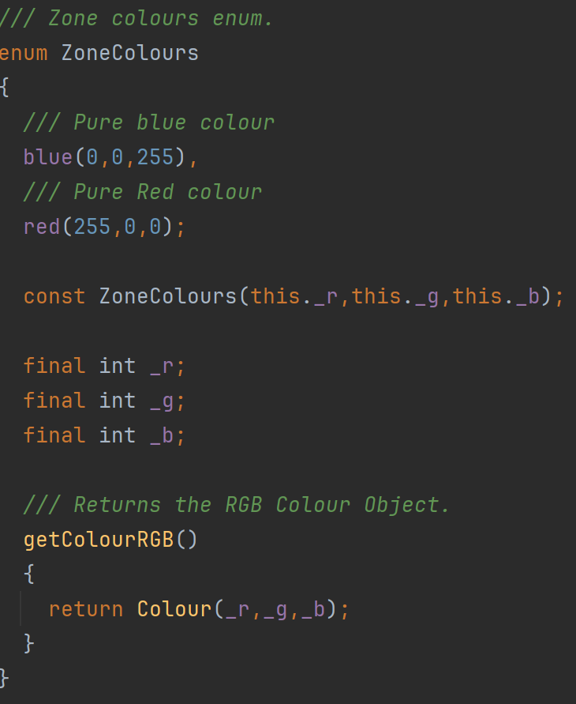

GradZones extends Iterable so that the zones can be easily looped through. GradZones also provides a method for the zones to be given as a sorted list by alphabetical order of their ID’s. This is to display on the profile screen. Sorting by alphabetical order of the ID’s will keep the order they are displayed consistent without actually ordering them by any meaningful characteristic.

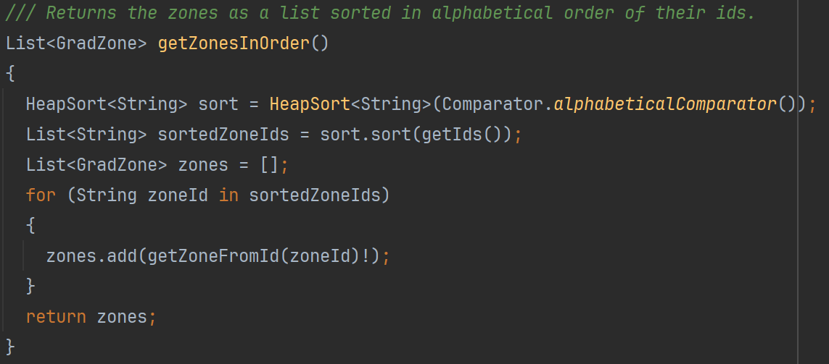

The sorting algorithm used is the heap sort as it is efficient for all input sizes and so it can be reused to sort larger datasets if needed.

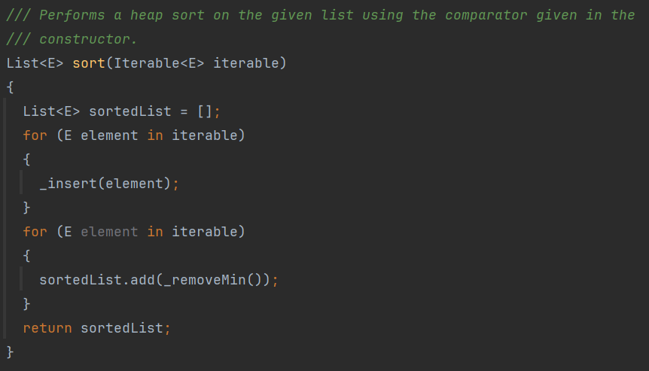

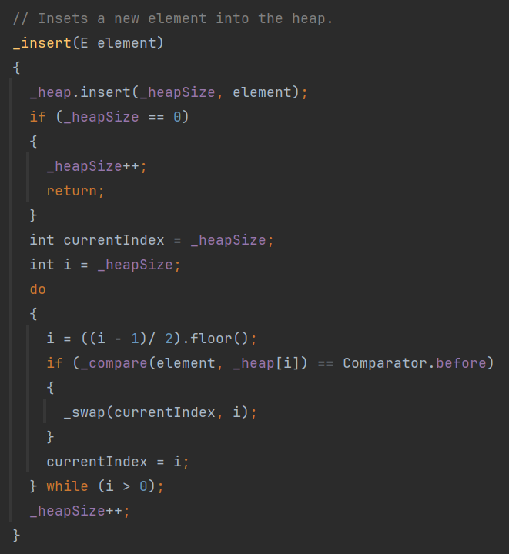

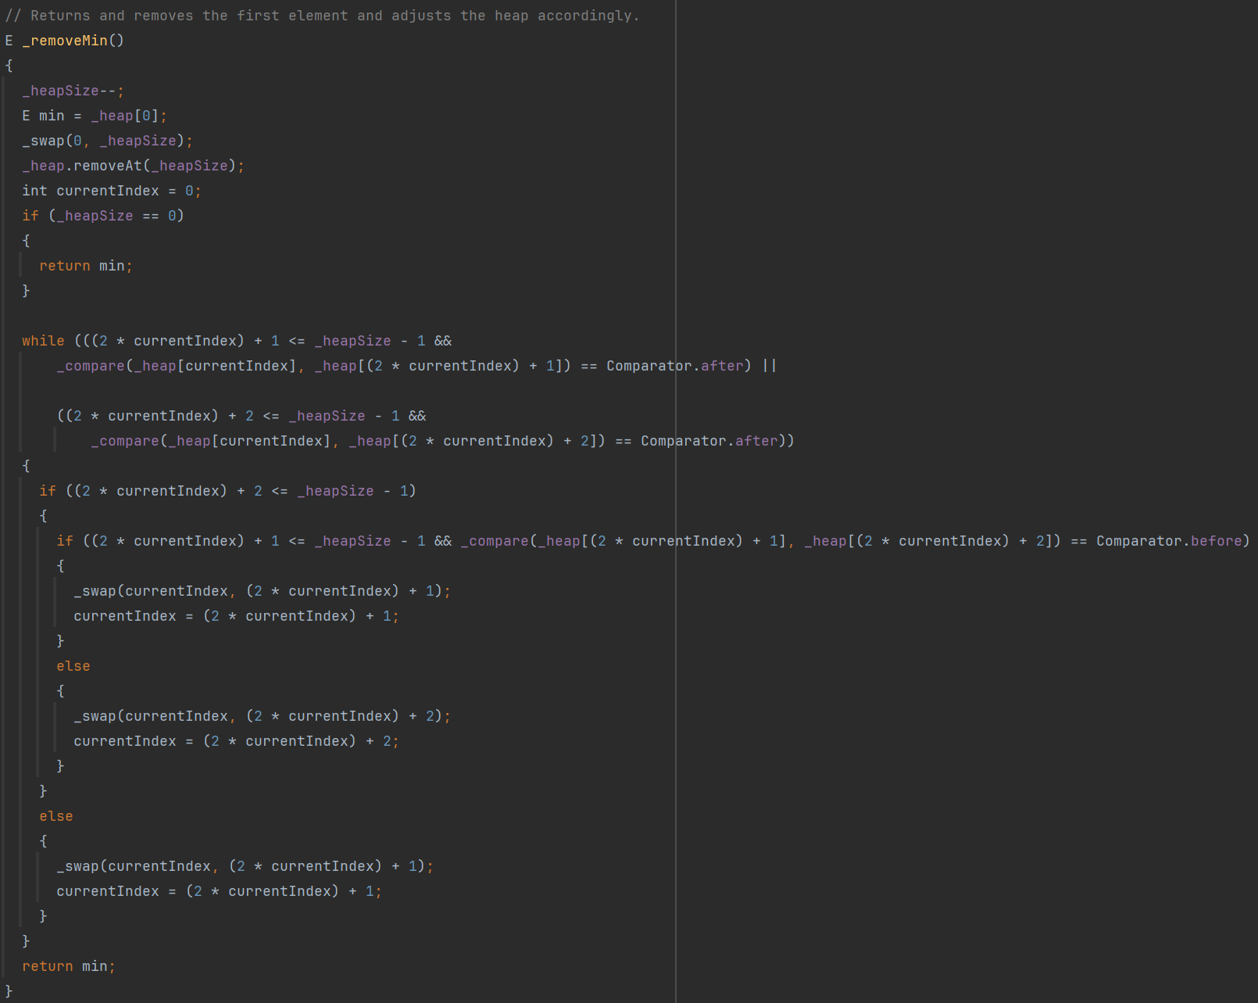

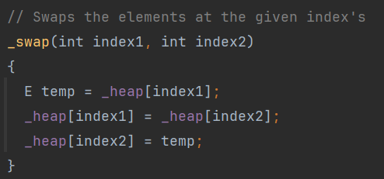

This heap sort also takes a comparator to sort the elements making it highly reusable.

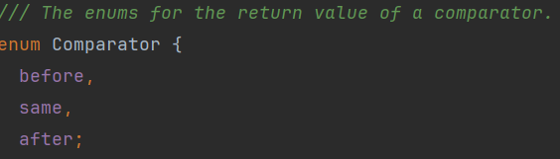

The comparator used to sort the zones is as follows:

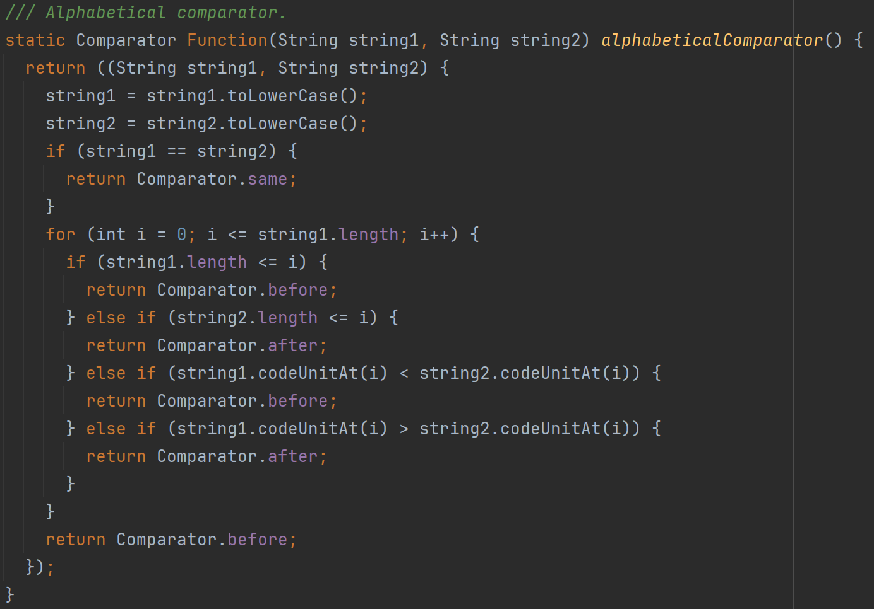

### Task 2 – Profile Screen

The profile screen allows a user to set their name, faculty, school, course, and finally which graduation zones they would like to appear in. The final design is as shown below.

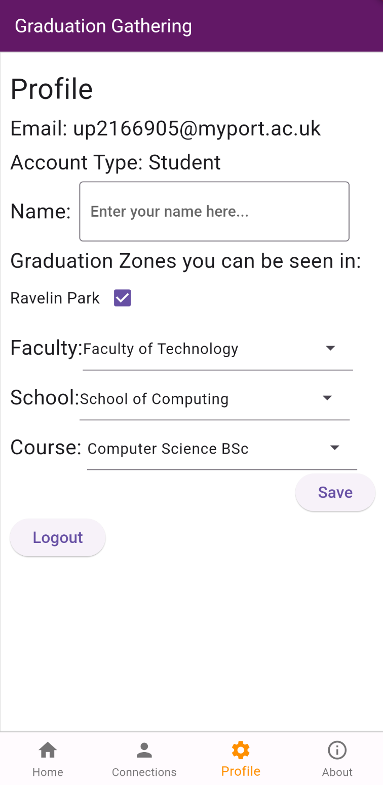

The faculties, schools and courses as seen from the profile screen are stored in the AcademicStructure class. This data structure stores the values in a Map<String, Map<String, Set<String>>>, in easier terms, it stores the values as a Map<Faculty, Map<School, Set<Course>>>. This allows for it to return all the faculties, all the schools, all the courses, all the schools in a faculty and all the courses in a school very efficiently and, for a data structure this small for importantly, the code to do so is very readable and editable.

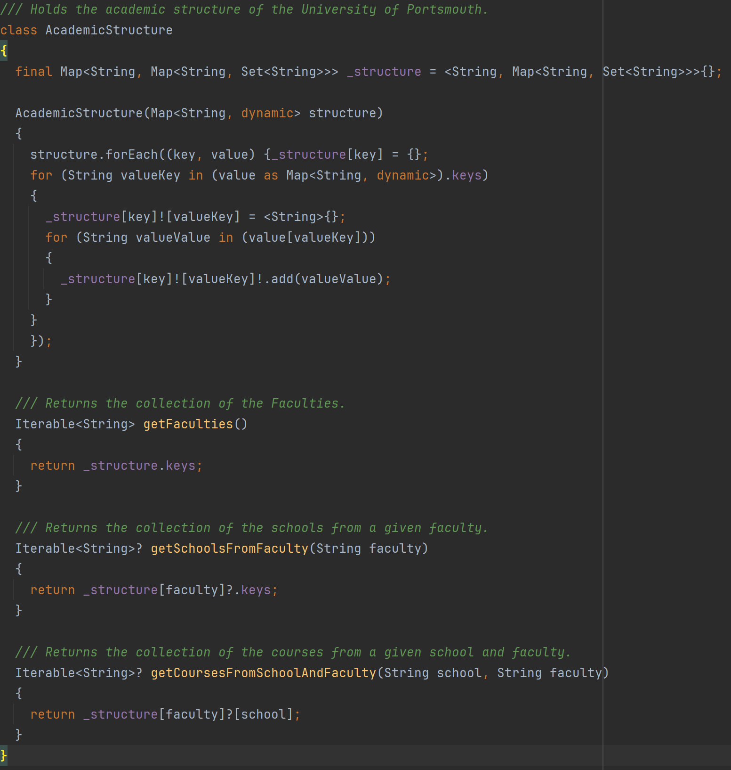

The account type of the user is also stored as an enum to simplify the code for when not to display courses to staff users.

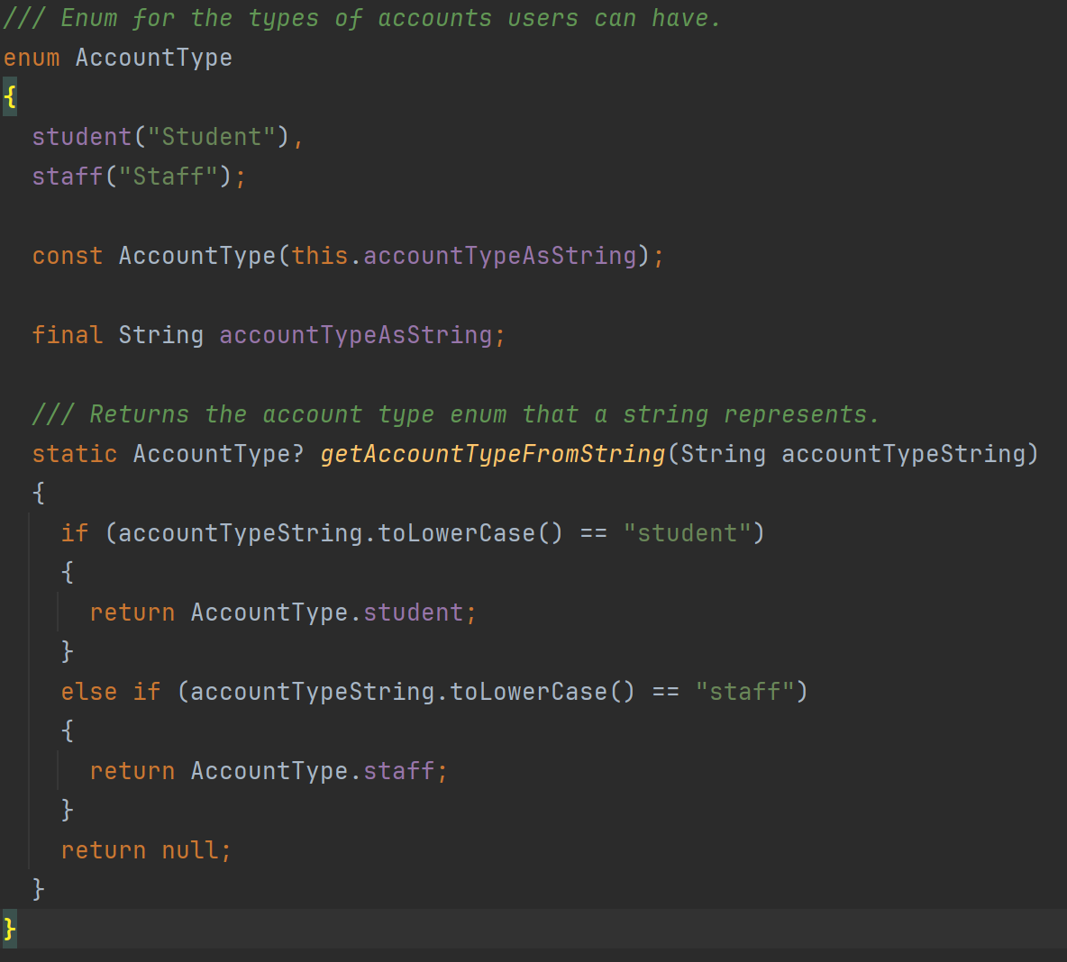

### Task 3 – Connections Screen

The connections screen has two parts, the first displays the connections you currently have, and the second allows you to request permission to see other users to connect with them.

Below is the connections screen when you have an incoming connection request, and then when you have one connection.

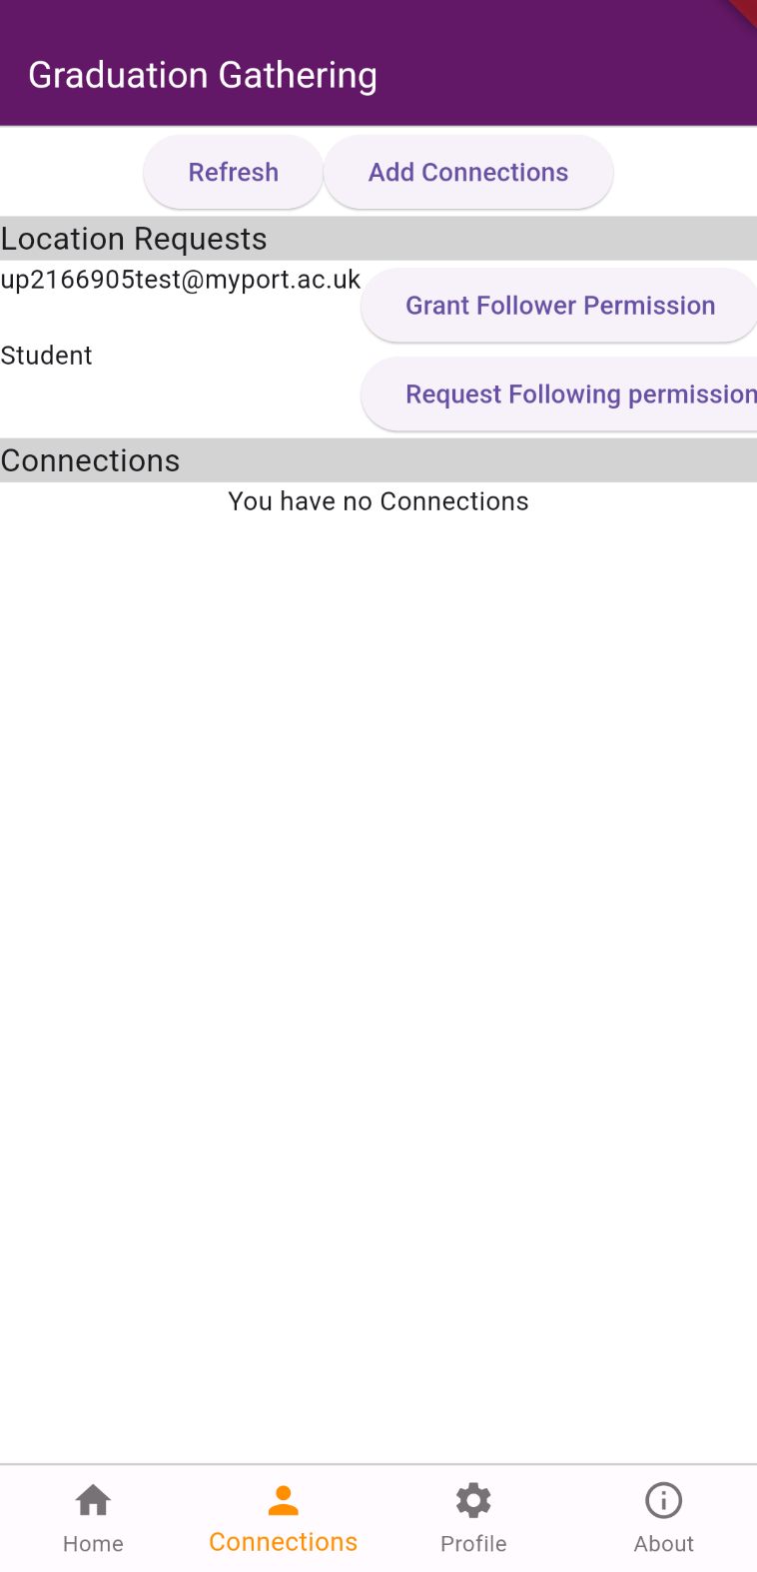 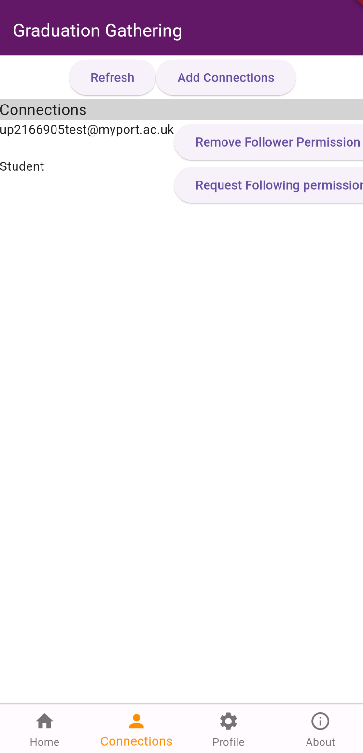

The following is the add connections screen when you are searching for a user.

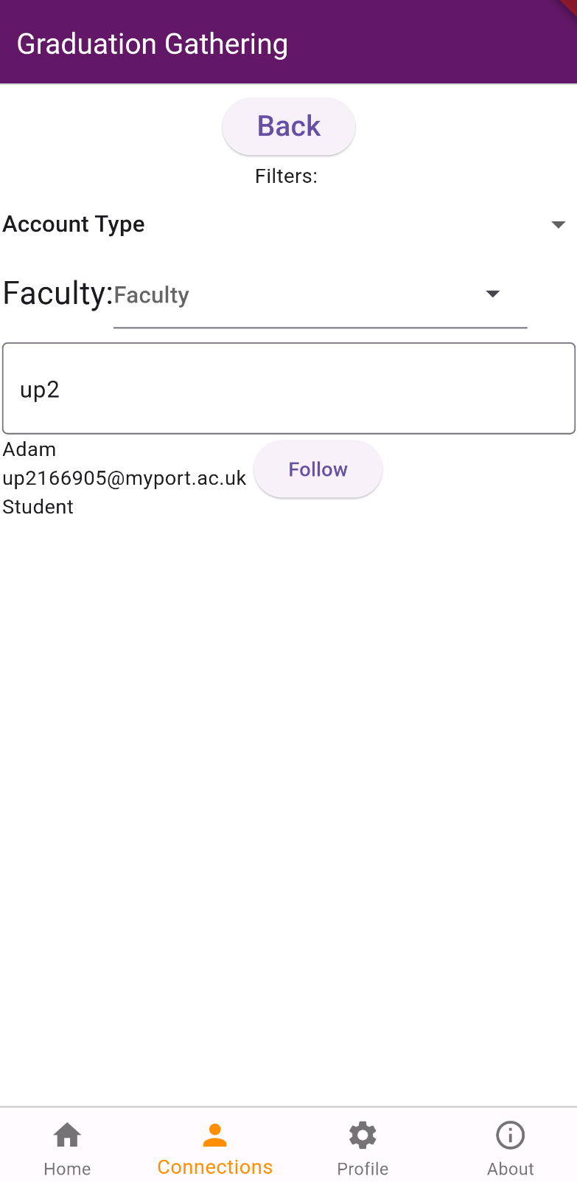

The connections are stored in the Connections class, which extends Iterable so that the connections can be easily looped through. They are parsed and transformed from the format User A, User B, permission (I.e. granted or request) into the format, User that is not this phone’s user, permission from this user to that user, permission to this user from that user. This parsing is done by the code below.

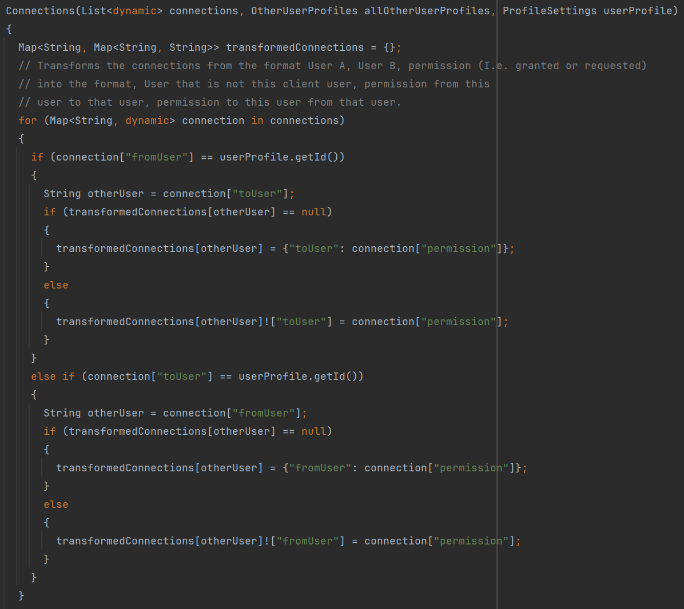

### Sprint 3 Summary

Graduation Gathering, from front-end to back, is now complete. Not all requirements have been met, but most have and the most important features have been added. This sprint has seen the UI being built and become responsive as well as the data needed to power the app being stored effectively in various data structures.